**NAAN MUDHALVAN PROJECT**



**PROJECT TITLE**

**FLIGHT BOOKING APPLICATION USING MERN**

**Submitted by team members of Final Year IT-B:**

**SHANJANA P – 311421205080**

**ROSHINI P – 311421205073**

**NISHA K - 31142120508059**

**NARMADHAA S - 311421205057**

**MEENAKSHI COLLEGE OF ENGINEERING**



**12, VEMBULIAMMAN KOVIL STREET, WEST K.K. NAGAR, CHENNAI – 600078, TAMILNADU,**

**(AFFILATED TO ANNA UNIVERSITY)**

**FLIGHT BOOKING APPLICATION USING MERN**

**ABSTRACT:**

The Flight Booking Application is a comprehensive system designed using the MERN (MongoDB, Express.JS , React.JS , Node.JS) stack to provide seamless and efficient booking experiences for users. Leveraging the power of a No SQL database (MongoDB), the application ensures scalability over data storage for user profiles, flight schedules, and booking details. The React.JS based front-end delivers a dynamic and interactive user interface, enabling users to browse flights, select options, and manage their bookings effortlessly. Node.JS and Express.JS handle back-end processes, ensuring smooth communication between the client and server.

The system incorporates essential features such as user authentication, real-time flight search, and secure payment integration, providing an end-to-end solution for flight reservations. Built with Restful API architecture, the back-end ensures scalability, enabling robust interaction with external API for live flight data. The application is designed to handle a high volume of concurrent users, employing optimized query strategies and state management solutions like REDUX to maintain responsiveness and efficiency.

This project emphasizes modern development practices such as responsive design, ensuring accessibility across various devices, and implementing security measures like data encryption and input validation to protect sensitive user information. With the MERN stack's full-stack JavaScript capabilities, the application demonstrates high maintainability, flexibility, and readiness for future enhancements.

# TABLE OF CONTENTS:

**ABSTRACT**

**1.INTRODUCTION**

* 1. Project name
  2. Team Members and their roles
  3. Project Functionality

1. **PROJECT OVERVIEW**

**2.1.** Purpose

**2.2.** Features

**3.SYSTEM REQUIREMENTS**

**3.1.** Hardware

**3.2.** Software

**3.3.** Network

**4.ARCHITECUTRE**

**4.1.** Technical Architecture

**5. ER DIAGRAM**

**5.1.**Users Entity

**5.2.** Admin Entity

**5.3.** Flight Operator

**6.SET UP INSTRUCTIONS**

**6.1.** Front-end Development

**6.2.** Back-end Development

**6.3.** Database Development

**7.PROJECT FOLDER STRUCTURE**

**7.1.** Front-end Architecture **(CLIENT)**

**7.2.** Back-end Architecture **(SERVER)**

1. **APPLICATION FLOW**
   1. Working of Admin
   2. Working of Flight Operator
   3. Working of Customer
2. **COMPILING THE APPLICATION**
3. **API DOCUMENTATION**
4. **PROJECT IMPLEMENTATION**
5. **AUTHENTICATION AND AUTHORIZATION**
6. **EXECUTION OF USER INTERFACE**
7. **TESTING OF OUR APPLICATION**
8. **EXECUTION OF THE APPLICATION**
9. **OBSERVER ISSUES**
10. **FUTURE ENHANCEMENT**
11. **CONCLUSION**

**INTRODUCTION:**

**PROJECT NAME:**

**FLIGHT BOOKING APPLICATION USING MERN**

**TEAM MEMBERS AND THEIR ROLES:**

* **SHANJANA P - ROLE:**

Back-end Developer, responsible for building restful API, managing server-side functionality & ensuring data security using Node.JS & Express.

* **ROSHINI P - ROLE:**

Project Lead & Front end Developer, responsible for coordinating the team, overseeing project milestones, and ensuring timely completion of deliverable and also focusing on designing & implementing the user interface using React & Material UI.

* **NISHA K - ROLE:**

Database Administrator, in charge of managing of the MongoDB database, handling data storage& ensuring efficient data retrieval & integrity.

* **NARMADHAA S - ROLE:**

Front-end Developer, focusing on designing & implementing the user interface using React & Material UI for an engaging and intuitive user experience.

**PROJECT FUNCTIONALITY:**

Our project focuses on developing an application where it enhances the overall **User Experience(UI)** and focuses on enhancing the Booking application through providing clear details of the Flight.

Before knowing about the **Purpose** of our project I would like to inform to you people how good our application has been developed and what are the key features we have used to enhance the productivity of our application and how well it satisfies the usage of our application.

Before knowing about the entire project features and the **Technical stacks functionality,** I would like to give a detailed intro regarding

1. **What is MODEL, VIEW AND CONTROLLER and a brief explanation regarding it.**
2. **Then, I would like to go with the functionality of our Flight Booking application and how our application’s model, view and Controller works.**

**WHAT IS MVC AND WHY ITS IMPORTANT IN THE APPLICATION WE ARE GONNA DEVELOP:**

**Model-View-Controller (MVC)** is a design pattern widely used in software development, particularly in web applications. It divides an application into three interconnected components, each responsible for a distinct aspect of the application’s functionality. This separation helps manage the complexity of the application, improve maintainability, and allow developers to work more efficiently by focusing on one aspect of the application at a time.

**1. Model:**

* **Definition**: The **Model** is responsible for managing the data and business logic of the application. It defines how data is stored, retrieved, and manipulated, and it represents the "real-world" entities in the application.
* **Role**: It communicates with the database, applies business rules, and manages the data structure.

**2. View**

* **Definition**: The **View** is the presentation layer of the application. It is responsible for displaying the data to the user and defining the structure and layout of the UI.
* **Role**: The View interacts with the user and reflects the data provided by the Model.

**3. Controller**

* **Definition**: The **Controller** acts as the intermediary between the Model and View. It processes user inputs, communicates with the Model to fetch or update data, and determines which View to display.
* **Role**: The Controller interprets user inputs from the View, updates the Model, and then selects the appropriate View for the user.

Here’s a clear illustration of how a MVC Architecture diagram look like:

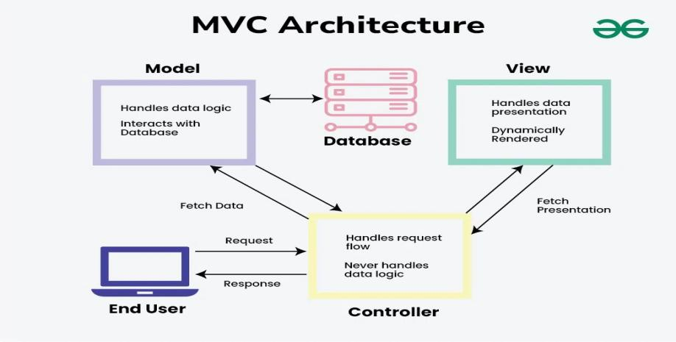

**HOW THE MVC ENHANCES THE OVERALL FUNCTIONING OF OUR APPLICATION?**

Since our application is built using React for the frontend and Node.js for the backend, it follows the Model-View-Controller (MVC) design pattern to organize the code effectively and improve functionality.

**Model:** We use MongoDB as our database to store and manage information such as flight data, user profiles, and booking details. MongoDB’s flexible, schema-less structure allows us to store data in a variety of formats, making it adaptable and scalability. The Model layer handles all database interactions, providing a seamless and optimized data experience for the application.

**View:** Our React front-end serves as the View layer, creating an interactive and responsive user interface for users to explore flights, manage bookings, and view details. React' s component-based design enables a modular approach, ensuring that the UI is engaging and easy to update. This layer solely focuses on the presentation and does not handle data directly, making it easier to maintain and scale the UI independently.

**BY FOLLOWING THE MVC PATTERN, WE’VE CREATED A STRUCTURE THAT:**

1. Separates concerns between data management, UI presentation, and business logic:

By isolating the different concerns (data, UI, and user input), MVC makes your code base more organized and easier to maintain. Changes to one part of the system (e.g., updating the UI) can be made without affecting the business logic or data processing.

1. Enhances the app’s scalability and maintainability, making it easy to introduce new features:

The functionality of MVC allows the application to grow over time by adding new features or supporting more complex interactions without significant refactoring. Each part can be worked on independently.

1. Provides a responsive and efficient user experience, with a back-end that ensures data consistency and security:

MVC allows developers to maintain a clear structure where each component is responsible for a specific part of the functionality, making it easier to fix bugs, implement changes, or add new features.

Now let’s understand:

1. **What’s a Flight Booking application?**
2. **Importance of using the Flight Booking application**

**WHAT’S A FLIGHT BOOKING APPLICATION?**

A flight booking application is a digital platform that allows users to search, compare, and book flights online.

Typically, it provides a user-friendly interface for travelers to:

* Search for flights based on destinations, dates, and preferences (like non-stop flights or preferred airlines).
* Compare flight options, including ticket prices, flight times, and layover details.
* Book tickets and pay securely, often offering multiple payment methods.
* Manage bookings, which includes making changes, checking flight status, or canceling reservations.
* Access additional services, such as seat selection, baggage options, and travel insurance.

**IMPORTANCE OF USING A FLIGHT BOOKING APPLICATION:**

Have you ever wondered why a Flight Booking Application was developed well it was just developed to reduce the overall time taken for any person to book their own tickets and to get disappointed if their tickets were not booked properly. In order to reduce all these stuffs our project works in reducing the time period for a particular person to go the airport and to book their ticket, they can do within a short period of time with this application.

**2.PROJECT OVERVIEW:**

**2.1. PURPOSE:**

**WHAT MAKES OUR APPLICATION DIFFERENT FROM OTHER APPLICATIONS?**

As mentioned above we have developed this application in such a way the User, Admin, the flight operator can use it without any authentication problem in it. For this we have used the **JSON Web Token** which focuses on maintaining authentication for the overall flight booking application.

**WHAT’S THIS JSON WEB TOKEN AND HOW IT HANDLES THOSE AUTHENTICATION FEATURES?**

**JSON Web Token (JWT)** is a compact, **URL-safe token** format used for securely transmitting information between parties as a **JSON object**. In the context of authentication, JWT allows a server to verify the identity of a client and authorize access to resources without needing to manage session data on the server side, making it popular for web applications, particularly in stateless architectures like REST API.

In a **flight booking application**, **JSON Web Tokens (JWT)** play a crucial role in handling authentication and securing user interactions with the system. Here’s how JWT authentication typically works within this type of application:

**KEY USES OF JWT IN A FLIGHT BOOKING APPLICATION:**

1. **User Authentication**:
   * When a user logs in (e.g., as a passenger, admin, or airline staff), the back-end server verifies their credentials (like username and password).
   * Upon successful login, the server generates a JWT containing key information (e.g., user ID, roles, and any permissions), then sends this token back to the client (front-end).
2. **Token Storage**:
   * The client (e.g., a web or mobile app) stores the JWT in a secure location, typically in local storage or cookies.
   * This token will be attached to every subsequent request that requires authentication, making the user’s session “stateless” on the server, as there is no need for session storage.
3. **Authorization**:

* Once authenticated, the JWT helps control access to specific resources based on user roles or permissions. For example:
  + **Passengers** can search for flights, make bookings, and view their booking history.
  + **Admins** can access booking records, manage flights, and oversee customer service requests.
  + **Airline Staff** might access check-in and boarding information for passengers.
* This separation ensures that only users with appropriate roles can access certain features or data, protecting sensitive information.

1. **Session Expiration and Token Refreshing**:

* JWT usually have an **expiration time** to improve security. For example, a token might expire after 24 hours.
* If a user’s session expires during usage, the client might request a new token using a **refresh token** (if implemented) or prompt the user to log in again.

1. **Security for Sensitive Data**:

* In a flight booking app, sensitive information (like payment details, booking confirmations, and personal data) is exchanged. JWT secure signature (includes algorithms like HMAC or RSA) ensures that token data is tamper-proof.
* Only a valid JWT signed by the server allows access to protected endpoints, adding a layer of security for customer information.

**2.2. FEATURES:**

**1.User Authentication**

**Sign Up and Login:** Users can register and log in with email/password or through third-party OAuth (e.g., Google, Facebook).

**Forgot Password:** Password recovery/reset functionality.

**Role-Based Access:** Separate access for customers and admin users.

**2. Search Flights**

**Flight Search:** Search flights by origin, destination, departure date, return date, and number of passengers.

**Filters and Sorting:** Filter by price, airline, stops, and duration. Sort by lowest price, shortest duration, or departure time.

**3. Flight Details**

**Flight Information:** Display detailed flight information, including airline, flight number, stops, layover duration, departure/arrival times, and prices.

**Seat Map:** Allow users to view and select available seats.

**4. Booking Management**

**Flight Booking:** Add selected flights to a cart and proceed to checkout.

**Booking Summary:** Display an overview of flight details, passengers, and total cost before confirming the booking.

**E-Ticket:** Generate and send a digital ticket to the user's email.

**5. Passenger Information**

**Form Inputs:** Collect passenger names, ages, genders, and special preferences (e.g., meals, assistance).

**Save Details:** Option to save passenger details for future bookings.

**6. Payment Gateway Integration**

**Multiple Payment Methods:** Support credit/debit cards, net banking, UPI, and wallets.

**Payment Confirmation:** Real-time payment status and booking confirmation.

**Promotions and Discounts:** Apply promo codes and display discounts.

**7. User Dashboard**

**Upcoming Trips:** Show upcoming bookings with details and status.

**Past Bookings:** Allow users to view and download past tickets.

**Favorites:** Save frequently searched routes or airlines.

**8. Admin Panel**

**Flight Management:** Add, update, or remove flight schedules.

**User Management:** View and manage user data.

**Booking Insights:** Analytic on bookings, revenue, and user trends.

**9. Real-Time Updates**

**Flight Status:** Display real-time flight status (delays, cancellations, gate changes).

**Notifications:** Push/email notifications for booking confirmations, reminders, or flight updates.

**10. Additional Features**

**Multi-City Booking:** Book flights with multiple destinations in one transaction.

**Currency Support:** Display prices in various currencies.

**Language Support:** Offer multilingual support for better accessibility.

**Loyalty Program:** Reward frequent users with points or discounts.

Customer Support: Provide chat or email support for queries and complaints.

**11. Mobile Responsiveness**

Ensure a seamless experience on desktop, tablet, and mobile devices.

**12. Security**

**Data Encryption:** Secure user data and transactions.

**Fraud Prevention:** Implement checks to detect and prevent fraudulent activities.

**3.1.SYSTEM REQUIREMENTS:**

The system requirements for any particular project is categorized into three main parts and those are:

* Hardware
* Software
* Network

Now let’s understand what are these three and get to know more about these:

**HARDWARE REQUIREMENTS**

The hardware requirements for a flight booking application include a reliable server with at least 16 GB of RAM, a multi-core processor to handle multiple user requests, and ample storage to manage user information, booking data, and flight details.

**SOFTWARE REQUIREMENTS**

The software requirements encompass a frontend framework such as React or Vite to build the user interface, a backend environment like Node.js for handling server operations, and a database management system like MongoDB or PostgreSQL for storing and managing application data. Essential development tools include an editor like VS Code for coding and Git for version control.

**NETWORK REQUIREMENTS**

The network requirements include a high-speed, stable internet connection to ensure consistent access, along with security protocols like SSL/TLS to protect sensitive user data. Additionally, a load balancer is recommended to distribute user traffic evenly across servers, maintaining performance during high-demand times.

**HOW ALL THESE THREE FEATURES ENHANCE THE OVERALL FUNCTIONALITY:**

**Hardware:**

**1. User Benefits:** Reliable server hardware ensures a faster response time and smoother experience, reducing booking delays and minimizing page load times.

**2.Admin/Flight Operator Benefits:** Robust hardware can handle large databases, allowing admins and operators to manage extensive records of bookings, schedules, and user data without system slowdowns.

**Software:**

1. **User Benefits:** A well-structured front-end framework (like React) provides users with an intuitive, easy-to-navigate interface, while a strong back-end ensures reliable booking functionality and quick search results.

**2**. **Admin/Flight Operator Benefits:** A powerful back-end setup enables admins to efficiently track flight schedules, manage bookings, and generate reports, while a secure database keeps sensitive data well-organized and accessible.

**Network:**

1. **User Benefits:** A stable, secure network with SSL/TLS ensures users feel confident sharing sensitive information, knowing their data is safe from breaches.

**2**. **Admin/Flight Operator Benefits:** A robust network with load balancing supports high traffic, allowing admins and operators to access the system simultaneously without performance issues, even during peak booking periods.

**4.ARCHITECTURE:**

The architecture focuses on how good an application has been designed and what are the basic functionalities which has been included for building the application.

Developing a flight booking app involves implementing various features and functionalities across the frontend, backend, database, and security layers. Here are key implementations often included in a flight booking application:

**1. User Authentication and Authorization**

* **User Registration and Login**: Implement user registration, login, and password reset functionalities.
* **Role-Based Access Control**: Different roles (e.g., passengers, admins, and airline staff) are created to restrict access to certain sections of the app.
* **JWT (JSON Web Token) Authentication**: For secure, stateless user sessions and to protect routes with authentication requirements.

**2. Flight Search and Filtering**

* **Search Flights**: Allow users to search for flights by entering departure and destination airports, dates, and the number of passengers.
* **Filter and Sort Options**: Implement filters for direct/indirect flights, airlines, departure/arrival times, and sorting options based on price, duration, or convenience.
* **Dynamic Pricing**: Integrate pricing data from different sources or APIs, as ticket prices may fluctuate based on demand, season, or other factors.

**3. Booking and Payment System**

* **Flight Booking**: Implement booking forms where users can input passenger details, seat preferences, and other information.
* **Seat Selection**: Display seating arrangements and allow passengers to choose seats (if applicable).
* **Payment Integration**: Integrate secure payment gateways (e.g., Stripe, PayPal) to process transactions.
* **Booking Confirmation and Email Notification**: After successful payment, generate a booking confirmation and send it via email, possibly including an e-ticket.

**4. Flight Management for Admins**

* **Flight Schedules and Availability**: Admins should be able to manage flight schedules, add new flights, and update availability.
* **Pricing Management**: Allow admins to adjust pricing, apply discounts, or manage seat classes.
* **User Management**: Admin functionality for managing user accounts, handling customer service inquiries, and reviewing booking history.

**5. Database Design and Management**

* **Entity-Relationship (ER) Diagram**: Design an ER diagram representing key entities like Users, Flights, Bookings, Payments, and Notifications.
* **Database Indexing and Optimization**: Optimize the database with indexing and caching for quick access to frequently queried data, such as flight schedules and availability.
* **Data Backup and Security**: Regularly back up the database and ensure data security through encryption, access control, and periodic audits.

**6. Backend Development and APIs**

* **RESTful API Development**: Build APIs for handling core functionalities like flight search, booking, user management, and payments.
* **Data Validation and Error Handling**: Implement robust validation checks for incoming data and manage errors gracefully.
* **Scalability and Load Balancing**: Design the backend to handle high traffic volumes, especially during peak travel seasons.

**7. Testing and Deployment**

* **Automated and Manual Testing**: Perform unit testing, integration testing, and end-to-end testing to ensure stability.
* **Deployment Pipeline**: Set up CI/CD (Continuous Integration and Continuous Deployment) pipelines to streamline testing and deployment.
* **Monitoring and Logging**: Integrate monitoring (e.g., using tools like New Relic or Data Dog) to track application performance and error logs.

**5.ER DIAGRAM:**

**WHAT IS AN ER DIAGRAM:**

An **ER Diagram (Entity-Relationship Diagram)** is a visual representation of the entities, attributes, and relationships in a database. It is a critical tool in database design, used to structure and model how data is stored, organized, and interrelated.

**KEY FEATURES OF USING ER DIAGRAM:**

Entities: Represent the main objects or concepts in the system.

Depicted as rectangles.

Examples: User, Flight, Admin.

Attributes: Represent properties or details of an entity.

Depicted as ovals connected to entities.

Examples: For a User, attributes could be user_id, name, email.

Relationships: Represent associations between entities.

Depicted as diamonds connecting related entities.

Examples: A User "books" a Flight.

Primary Key: A unique identifier for each entity instance.

Often underlined in the diagram (e.g., user_id).

Cardinality: Describes the number of relationships between entities.

**Examples:**

1-to-1: One entity relates to only one other entity.

1-to-Many: One entity relates to multiple entities.

Many-to-Many: Multiple entities relate to multiple entities.

**Purpose of an ER Diagram**

**Database Design:** Helps structure the database schema by identifying tables and their relationships.

**Clarify Requirements:** Simplifies understanding of how different parts of a system interact.

**Communication Tool:** Facilitates discussion among developers, analysts, and stakeholders.

Now let’s focus on how these three enhance the functionality of application:

**5.1.USER’S ENTITY:**

The ER Diagram for a flight booking application includes key entities such as User, Admin, and Flight Operator, each representing distinct roles and functionalities. Here’s a detailed description:

**Attributes:**

user_id (Primary Key): A unique identifier for each user.

name: Full name of the user.

email: Email address for communication and login.

password: Encrypted password for authentication.

phone_number: Contact number of the user.

preferences: User preferences such as seat type, meal options, etc.

booking_history: Links to the bookings made by the user.

**Relationships:**

1-to-Many with Booking: A user can make multiple bookings, but each booking belongs to one user.

Many-to-Many with Flight: Users can search for and book flights; each flight can have many users.

**5.2. ADMIN ENTITY**

**Attributes:**

admin_id (Primary Key): A unique identifier for each admin.

name: Name of the admin.

email: Email address for login and communication.

password: Encrypted password for secure login.

role: Defines admin roles (e.g., Super Admin, Flight Manager).

**Relationships:**

1-to-Many with Flight Operator: An admin oversees multiple flight operators.

1-to-Many with Flights: Admins have control over managing flight details (CRUD operations).

**5.3. FLIGHT OPERATOR ENTITY**

**Attributes:**

operator_id (Primary Key): Unique identifier for each flight operator.

operator_name: Name of the airline or flight operator.

contact_info: Contact details of the operator.

fleet_size: Number of aircraft managed by the operator.

schedule: Details about flight schedules managed by the operator.

**Relationships:**

1-to-Many with Flights: A flight operator manages multiple flights.

1-to-Many with Admin: Flight operators work under the supervision of admins.

Connecting Relationships

**Bookings Entity (Associative):**

Contains booking_id as the primary key, linking users and flights.

Attributes include flight details, user details, seat selection, payment status, and timestamps.

**Flight Entity:**

Holds details about flights like flight_id, source, destination, departure_time, arrival_time, price, and operator_id.

**THE ER DIAGRAM FOR OUR APPLICATION HAS BEEN ILLUSTRATED BELOW:**

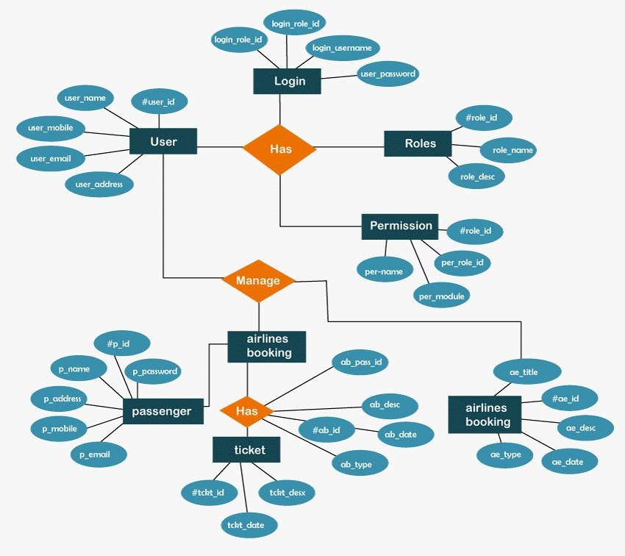

**6.SETUP INSTRUCTIONS:**

**6.1. FRONT-END DEVELOPMENT:**

**1. Front-end part:**

The front-end part usually focuses on enhancing the User Interface part and then this also analyses how well the application is developed for the user to enhance the user interactions and to update changes on the way they interact.

The very first part focuses on generating the **User Interface (UI)** which focuses on how the user interacts with the web page.

We have developed the application using **React** which focuses on **enhancing the overall user experience.**

Apart from that we have used **JSX (JavaScript XML)** which focuses on providing the **best User Interface UI experience** for the user who are using our application.

**INSTALLATION COMMAND PART FOR FRONT-END:**

The commands we have used for the installation of Front-end part include the following:

We have created a folder **Flight-Booking-App-MERN-main**. This includes two main sub folders within it which includes **the client folder** and **the server folder.**

**The Client folder:** This was created to update the installations of all the Front-end **part.**

**The server folder:** This was created to update all the back-end **and the database part** of the overall application.

The very first step is to direct to the respective folder.



Once when it is done, we need to redirect to the client folder.



**Command 1:** This focuses on installation of **React Vite**.

**npm install vite@latest ./**

**Command 2:** This focuses on installation of **all the dependencies** in the front-end part.

**npm install @testing-library/jest-dom @testing-library/react @testing-library/user-event axios bootstrap react react-dom react-router-dom react-scripts vite web-vitals**

**Command 3:** This focuses on running the client part.

**npm start**

**6.2. BACK-END DEVELOPMENT:**

**2. Back-end part:**

The next part is the server part which focuses on handling all the responses from the server side on the requests given by the user.

**INSTALLATION COMMAND PART FOR BACK-END:**

**Command 1**: This focuses on verifying the installations of all commands

**npm init -y**

**Command 2:** This focuses on installation of all the necessary packages for the server to run efficiently.

**npm install bcrypt body-parser cors express mongoose**

**Command 3:** This focuses on installation of nodemon.

**npm install nodemon -g**

**Command 4:** This focuses on providing the successful connection of database.

**nodemon index.js**

**6.3. DATABASE DEVELOPMENT:**

The last part is something which focuses on handling the database. This is the part where the stored data in Database is fetched by the **Application Programming Interface (API)** for enhancing the overall back-end part.

**INSTALLATION COMMAND PART FOR DATABASE:**

The database part focuses on connecting the database to the server.

For this, we have focused on connecting the MongoDB Atlas cluster Connection string into the MongoDB compass. Alternatively, we have also focused on installation of **MongoDB for VS code** and then, we have entered our connection string on connecting to the database.

**7.PROJECT FOLDER STRUCTURE:**

A project structure in a MERN stack project refers to the organized layout of folders and files to maintain clarity, scalability, and maintainability throughout the development process. A well-structured project ensures smooth development and easier debugging.

The project folder structure focuses on analyzing how the **Client** and **Server** focuses on enhancing the overall application.

**PURPOSE OF PROJECT DIRECTORY:**

The purpose of a project directory is to provide a structured and organized way to manage all the files, folders, and resources associated with a project. This organization is crucial for ensuring smooth development, collaboration, scalability, and maintainability. Here's a breakdown of its purposes:

**1. Centralized Management**

Acts as a central repository for all project-related files, including code, assets, configuration, and documentation.

**2. Code Organization**

Groups related files and modules into directories (e.g., separating frontend, backend, and shared resources) for better readability and maintainability.

**3. Scalability**

Enables easy addition of new features or modules without disrupting existing functionality due to the organized structure.

**4. Collaboration**

Facilitates teamwork by providing a clear, predictable structure that developers can easily navigate, reducing onboarding time.

**5. Maintainability**

Simplifies debugging and updates by categorizing logic, assets, and configurations into distinct directories.

**6. Separation of Concerns**

Divides responsibilities (e.g., frontend UI, backend logic, database models) into dedicated sections to ensure modularity and reusability.

**7. Environment Setup**

Contains configuration files (e.g., .env, package.json, webpack.config.js) for setting up the environment, managing dependencies, and automating tasks.

**8. Version Control**

Provides a clear structure for managing changes with tools like Git, ensuring consistent collaboration and tracking of updates.

**9. Deployment**

Prepares the application for smooth deployment by organizing production-ready builds, assets, and server configurations.

**10. Documentation**

Houses documentation files like README.md to explain the purpose, setup, and usage of the project, making it accessible to new users or contributors.

**Project Root**

The main directory containing all the project's folders and files.

**FORMAT OF THE ROOT STRUCTURE:**

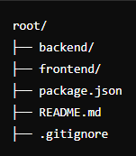

**THE BELOW ONE PROVIDES A CLEAR EXPLANATION OF HOW THE ENTIRE PROJECT DIRECTORY OF OUR APPLICATION LOOKS LIKE:**

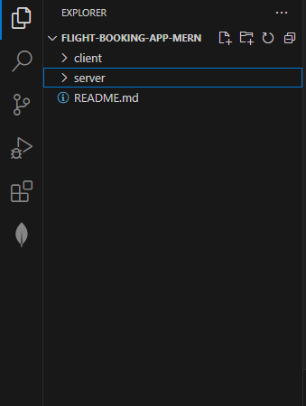

**7.1. FRONT-END ARCHITECTURE(CLIENT):**

**FORMAT OF HOW A CLIENT(FRONTPART) PROJECT DIRECTORY LOOKS LIKE:**

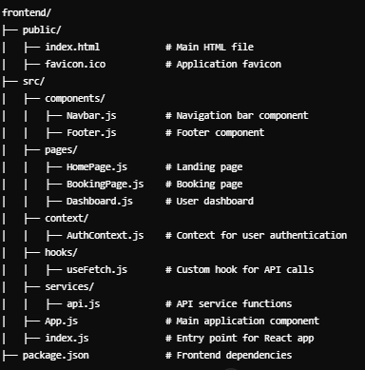

Now this is how our **CLIENT** part looks like:

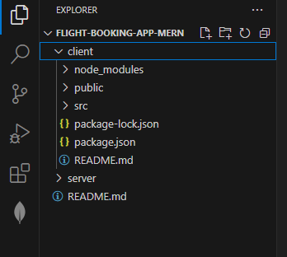

**7.1. BACK-END ARCHITECTURE(SERVER):**

**FORMAT OF HOW A SERVER(BACKEND) PROJECT DIRECTORY LOOKS LIKE:**

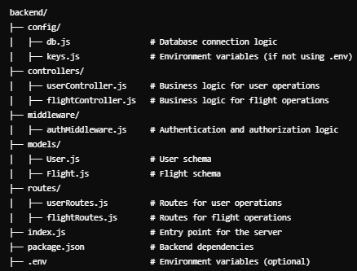

Now this is how our **SERVER** part looks like:

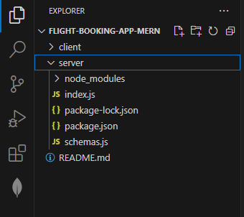

**Benefits of This Structure:**

**Modularity:** Separation of front-end and back-end for independent development.

**Scalability:** Easy to add new features or modules without clutter.

**Maintainability:** Clear distinction between logic, routes, components, and configurations.

1. **APPLICATION FLOW:**
   1. **WOKING OF ADMIN:**

The very first thing our users do is to get signed in to our Web page on directing directly to the Login page.

Once when this is done, then the next part is to deal with Registering to the Sign up page. This sign up page is open to

* **Admin**
* **Flight Operator**
* **Customer.**

Let us focus on the Role of the Admin:

**Role of Admin:**

The admin is the one who focuses on managing the booked and canceled tickets.

**WORKFLOW OF THE ADMIN:**

**STEP1:** Manages all bookings.

**STEP 2:** Adds new flights and services.

**STEP 3:** Monitor User activities.

* 1. **WORKING OF FLIGHT OPERATOR:**

**Role of Flight operator:**

The Flight operator is the one who ensures on the number of successful bookings and the number of failed bookings.

**WORKFLOW OF THE FLIGHT OPERATOR:**

**STEP1:** Manages all bookings.

**STEP 2:** Adds new flights and services.

**STEP 3:** Monitor User activities.

**STEP 4:** They can only look on user activities and edit or flights only when they get an approval from the **Admin.**

* 1. **WORKING OF CUSTOMER:**

**Role of the Customer:**

The Customer is the one who books the tickets and cancels those when they don’t need it.

**WORK FLOW OF THE USER:**

**STEP 1:** Create their account.

**STEP 2:** Search for the destination.

**STEP 3:** Search for flights as per his time convenience.

**STEP 4:** Book a flight with a particular seat.

**STEP 5:** Make payment.

**STEP 6:** To cancel bookings.

**BELOW ONE IS A SIMPLE ILLUSTRATION OF HOW OUR APPLICATION WORKS:**

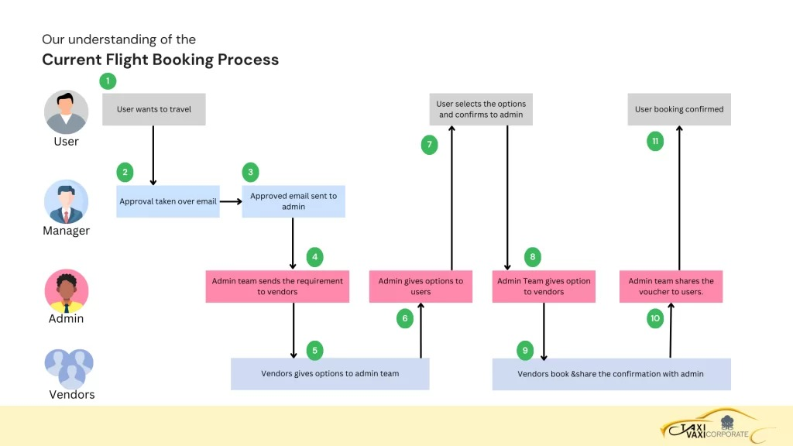

1. **COMPILING THE APPLICATION:**

Compiling the application means the **User** needs to focus on how to run the application and what are the tasks invloved in it.

Let’s know more about how the **Package.JSON** file of our application looks like:

Once when you are done with all the installation of necessary dependencies and packages now your package.json file for both Frontend and backend will look like this:

**PACKAGE.JSON FOR FRONTEND:**

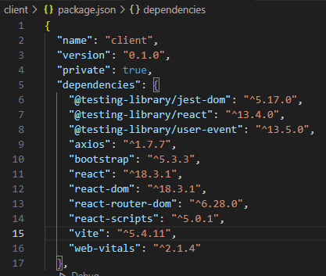

**PACKAGE.JSON FOR BACKEND:**

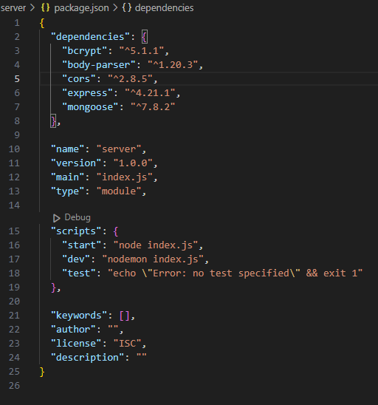

The next one is to explore package.json file in each folder(for both the client and the server folder).

**What’s package.json file?**

This is a configuration file used in Node JS. This file is basically used to manage the dependencies, metadata and scripts.

**FOR COMPILING THE FRONTEND PART(CLIENT):**

**The installation commands for front end include the following:**

**STEP1:** To redirect to the particular folder.





**STEP 2:** To install **React vite**.



After entering this command we encountered some errors and we actually focused on clearing those by providing the **npm audit fix** and we have reduced the vulnerabilities.

**STEP 3:** To install the necessary dependencies:



**STEP 4:** To run the **Client** part:

Once when we have provided the **npm start**, we have got the following and the application started to load in the browser.

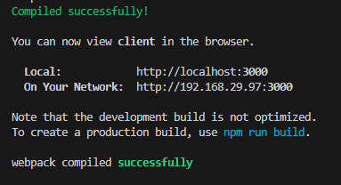

**FOR COMPILING THE BACKEND PART(SERVER):**

**STEP 1:** To redirect to the **server** folder.



**STEP 2:** To ensure the installation of node in the server folder, we have provided the following command:



We have got the following on providing the above command:

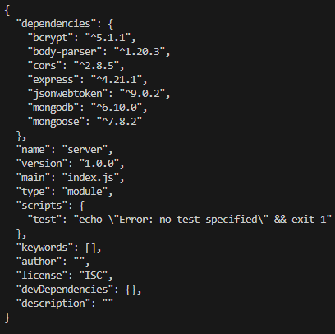

**STEP 3:** To install the respective dependencies for the backend folder.

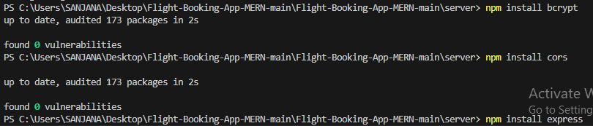

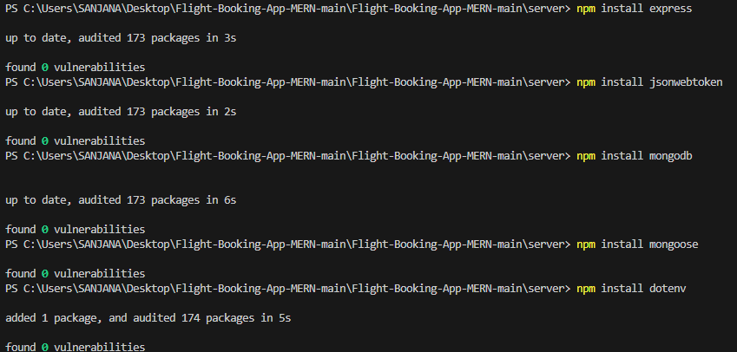

**STEP 4:** To install nodemon for running the server.

**What’ s nodemon?**

Nodemon is a utility for Node.js applications that automatically restarts the server when it detects changes in the code. This makes development more efficient by saving you the step of manually restarting the server each time you make changes to your code.



**STEP 5:** To run the server.



This generates the following output.

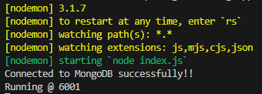

1. **API DOCUMENTATION:**

**IMPORTANCE OF API AND ITS FUNCTIONALITY:**

**Importance of REST API:**

**Standardized Communication:** REST APIs use standard HTTP methods (GET, POST, PUT, DELETE) for communication, which makes them easy to understand and implement.

**Statelessness:** REST APIs are stateless, meaning each request from a client to the server must contain all the information the server needs to process that request. This simplifies server design and makes it easier to scale.

**Separation of Concerns:** REST APIs separate the client and server, allowing the backend logic to evolve independently of the frontend user interface.

**Scalability:** REST APIs can easily scale because they can handle large amounts of traffic by distributing requests across multiple servers.

**Interoperability:** REST APIs allow different systems, written in various programming languages, to communicate with each other. This is especially important in a microservices architecture where multiple services need to interact.

**Mobile and Web Integration:** REST APIs are commonly used in mobile applications and single-page web applications (SPAs), enabling them to communicate efficiently with backend servers and databases.

**Caching:** REST supports caching of responses, reducing server load and

**THE API PART:**

The main function of an API (Application Programming Interface) is to facilitate communication between different software applications, enabling them to share data and functionality without needing to know each other’s inner workings. APIs define a set of rules, protocols, and tools that allow applications, servers, and services to interact seamlessly, enhancing flexibility and integration.

**1. Data Access and Communication**

* APIs allow applications to request and retrieve data from other services, acting as a bridge for data exchange. For example, a weather app can request data from a weather API to show forecasts.
* **REST APIs** (most common) follow HTTP protocols, sending data in formats like JSON or XML, making it easy to read and process on different platforms.

**2. Functionality Exposure**

* APIs allow applications to use each other’s functions or features. For instance, a flight booking app can use an API to access an airline's flight search and booking functions.
* By exposing only necessary functions, APIs let applications access a service's capabilities without exposing the underlying code or infrastructure.

**3. Interoperability**

* APIs enable interoperability between different systems, platforms, and programming languages, allowing diverse systems to communicate. This makes APIs ideal for creating cross-platform applications, where multiple services work together in a coordinated way.

**4. Automation**

* APIs allow tasks to be automated by enabling applications to make requests to each other without manual input. For instance, a content management system (CMS) might use an API to automatically publish content to social media platforms at scheduled times.

**5. Modularity and Reusability**

* APIs promote modularity by letting developers access specific functions or data without rebuilding these from scratch. This approach saves development time and improves code reuse, as functionalities are accessed and used as components.

**6. Enhanced User Experience (UX)**

* APIs enable real-time data updates and provide responsive interactions. For instance, in a flight booking application, APIs can retrieve real-time flight data and availability, improving user satisfaction by presenting current information instantly.

**7. Security and Controlled Access**

* APIs act as a layer between the application and data, often requiring authentication (like API keys, OAuth) to secure data. This controlled access ensures only authorized users or applications can interact with the API and access sensitive information.

1. **PROJECT IMPLEMENTATION:**

Frontend refers to the part of a web application or website that users interact with directly. It encompasses everything that users experience visually and interact with, including the design, layout, and the elements of a web page. The frontend is responsible for how the content is presented to the user and how users can interact with the application.

**Why we have used React?**

React is a popular JavaScript library for building user interfaces, primarily for single-page applications where you need a fast and dynamic user experience. Developed by Facebook, React allows developers to create reusable UI components and manage the state of an application in an efficient way. Here are some of its key features:

1. One way data binding.
2. Virtual DOM.
3. Component-based architecture.
4. Performance Optimization.

**The backend part:**

The backend is the part of an application that operates behind the scenes, managing how the system works and handling data storage, security, and business logic. It acts as the intermediary between the frontend (what users see) and the database (where data is stored), and it ensures the application functions smoothly and securely.

**Why we have used Node js?**

Node.js is an open-source, cross-platform JavaScript runtime environment that enables developers to build server-side applications using JavaScript. Built on Chrome’s V8 JavaScript engine, Node.js allows JavaScript to run on the server side, extending its use beyond client-side scripting. Node.js is known for its non-blocking, event-driven architecture, which makes it highly efficient and ideal for building scalable applications.

**The database part:**

A database plays a central role in any application, particularly in systems that need to store, retrieve, update, and manage data effectively. In applications like a flight booking system or e-commerce platform, the database acts as the backbone, ensuring data integrity, accessibility, and security. Here's a breakdown of the database's role in applications:

1. Data Storage and Management
2. Data Retrieval and Querying
3. Data Consistency and Integrity
4. Data Scalability and Availability
5. Data Security and Access Control

**BELOW IS THE CODE FOR THE FRONTEND PART:**

**Client>>src>>Components>>login.jsx**

import React, { useContext } from 'react'

import { GeneralContext } from '../context/GeneralContext';

const Login = ({setIsLogin}) => {

const {setEmail, setPassword, login} = useContext(GeneralContext);

const handleLogin = async (e) =>{

e.preventDefault();

await login();

}

return (

<form className="authForm">

<h2>Login</h2>

<div className="form-floating mb-3 authFormInputs">

<input type="email" className="form-control" id="floatingInput" placeholder="name@example.com"

onChange={(e) => setEmail(e.target.value)} />

<label htmlFor="floatingInput">Email address</label>

</div>

<div className="form-floating mb-3 authFormInputs">

<input type="password" className="form-control" id="floatingPassword" placeholder="Password"

onChange={(e) => setPassword(e.target.value)} />

<label htmlFor="floatingPassword">Password</label>

</div>

<button type="submit" className="btn btn-primary" onClick={handleLogin}>Sign in</button>

<p>Not registered? <span onClick={()=> setIsLogin(false)}>Register</span></p>

</form>

)

}

export default Login

**Client>>src>>Components>>navbar.jsx**

import React, { useContext } from 'react'

import '../styles/Navbar.css';

import { useNavigate } from 'react-router-dom';

import { GeneralContext } from '../context/GeneralContext';

const Navbar = () => {

const navigate = useNavigate();

const usertype = localStorage.getItem('userType');

const {logout} = useContext(GeneralContext);

return (

<>

<div className="navbar">

{!usertype ?

<>

<h3 >SB Flights</h3>

<div className="nav-options" >

<p onClick={()=>navigate('/')}>Home</p>

<p onClick={()=>navigate('/auth')}>Login</p>

</div>

</>

:

<>

{usertype === 'customer' ?

<>

<h3 >SB Flights</h3>

<div className="nav-options" >

<p onClick={()=>navigate('/')}>Home</p>

<p onClick={()=>navigate('/bookings')}>Bookings</p>

<p onClick={logout}>Logout</p>

</div>

</>

: usertype === 'admin' ?

<>

<h3 >SB Flights (Admin)</h3>

<div className="nav-options" >

<p onClick={()=>navigate('/admin')}>Home</p>

<p onClick={()=>navigate('/all-users')}>Users</p>

<p onClick={()=>navigate('/all-bookings')}>Bookings</p>

<p onClick={()=>navigate('/all-flights')}>Flights</p>

<p onClick={logout}>Logout</p>

</div>

</>

: usertype === 'flight-operator' ?

<>

<h3 >SB Flights (Operator)</h3>

<div className="nav-options" >

<p onClick={()=>navigate('/flight-admin')}>Home</p>

<p onClick={()=>navigate('/flight-bookings')}>Bookings</p>

<p onClick={()=>navigate('/flights')}>Flights</p>

<p onClick={()=>navigate('/new-flight')}>Add Flight</p>

<p onClick={logout}>Logout</p>

</div>

</>

:

""

}

</>

}

</div>

</>

)

}

export default Navbar

**Client>>src>>Components>>Register.jsx**

import React, { useContext } from 'react'

import { GeneralContext } from '../context/GeneralContext';

const Register = ({setIsLogin}) => {

const {setUsername, setEmail, setPassword, usertype, setUsertype, register, setHomeBranch} = useContext(GeneralContext);

const handleRegister = async (e) =>{

e.preventDefault();

await register()

}

return (

<form className="authForm">

<h2>Register</h2>

<div className="form-floating mb-3 authFormInputs">

<input type="text" className="form-control" id="floatingInput" placeholder="username"

onChange={(e)=> setUsername(e.target.value)} />

<label htmlFor="floatingInput">Username</label>

</div>

<div className="form-floating mb-3 authFormInputs">

<input type="email" className="form-control" id="floatingEmail" placeholder="name@example.com"

onChange={(e)=> setEmail(e.target.value)} />

<label htmlFor="floatingInput">Email address</label>

</div>

<div className="form-floating mb-3 authFormInputs">

<input type="password" className="form-control" id="floatingPassword" placeholder="Password"

onChange={(e)=> setPassword(e.target.value)} />

<label htmlFor="floatingPassword">Password</label>

</div>

<select className="form-select form-select-lg mb-3" aria-label=".form-select-lg example"

onChange={(e)=> setUsertype(e.target.value)}>

<option value="">User type</option>

<option value="admin">Admin</option>

<option value="customer">Customer</option>

<option value="flight-operator">Flight Operator</option>

</select>

<button className="btn btn-primary" onClick={handleRegister}>Sign up</button>

<p>Already registered? <span onClick={()=> setIsLogin(true)}>Login</span></p>

</form>

)}

export default Register;

**Client>>src>>Context>>GeneralContext.jsx**

import React, { createContext, useState } from 'react';

import axios from "axios";

import { useNavigate } from "react-router-dom";

export const GeneralContext = createContext();

const GeneralContextProvider = ({children}) => {

const [username, setUsername] = useState('');

const [email, setEmail] = useState('');

const [password, setPassword] = useState('');

const [usertype, setUsertype] = useState('');

const [ticketBookingDate, setTicketBookingDate] = useState();

const inputs = {username, email, usertype, password};

const navigate = useNavigate();

const login = async () =>{

try{

const loginInputs = {email, password}

await axios.post('http://localhost:6001/login', loginInputs)

.then( async (res)=>{

localStorage.setItem('userId', res.data._id);

localStorage.setItem('userType', res.data.usertype);

localStorage.setItem('username', res.data.username);

localStorage.setItem('email', res.data.email);

if(res.data.usertype === 'customer'){

navigate('/');

} else if(res.data.usertype === 'admin'){

navigate('/admin');

} else if(res.data.usertype === 'flight-operator'){

navigate('/flight-admin');

}

}).catch((err) =>{

alert("login failed!!");

console.log(err);

});

}catch(err){

console.log(err);

}

}

const register = async () =>{

try{

await axios.post('http://localhost:6001/register', inputs)

.then( async (res)=>{

localStorage.setItem('userId', res.data._id);

localStorage.setItem('userType', res.data.usertype);

localStorage.setItem('username', res.data.username);

localStorage.setItem('email', res.data.email);

if(res.data.usertype === 'customer'){

navigate('/');

} else if(res.data.usertype === 'admin'){

navigate('/admin');

} else if(res.data.usertype === 'flight-operator'){

navigate('/flight-admin');

}

}).catch((err) =>{

alert("registration failed!!");

console.log(err);

});

}catch(err){

console.log(err);

}

}

const logout = async () =>{

localStorage.clear();

for (let key in localStorage) {

if (localStorage.hasOwnProperty(key)) {

localStorage.removeItem(key);

}

}

navigate('/');

}

return (

<GeneralContext.Provider value={{login, register, logout, username, setUsername, email, setEmail, password, setPassword, usertype, setUsertype, ticketBookingDate, setTicketBookingDate}} >{children}</GeneralContext.Provider>

)

}

export default GeneralContextProvider

**Client>>src>>Pages>>Admin.jsx**

import React, { useEffect, useState } from 'react'

import '../styles/Admin.css'

import { useNavigate } from 'react-router-dom'

import axios from 'axios'

const Admin = () => {

const navigate = useNavigate();

const [users, setUsers] = useState([]);

const [userCount, setUserCount] = useState(0);

const [bookingCount, setbookingCount] = useState(0);

const [flightsCount, setFlightsCount] = useState(0);

useEffect(()=>{

fetchData();

}, [])

const fetchData = async () =>{

await axios.get('http://localhost:6001/fetch-users').then(

(response)=>{

setUserCount(response.data.length -1);

setUsers(response.data.filter(user => user.approval === 'not-approved'));

}

);

await axios.get('http://localhost:6001/fetch-bookings').then(

(response)=>{

setbookingCount(response.data.length);

}

);

await axios.get('http://localhost:6001/fetch-flights').then(

(response)=>{

setFlightsCount(response.data.length);

}

);

}

const approveRequest = async (id) =>{

try{

await axios.post('http://localhost:6001/approve-operator', {id}).then(

(response)=>{

alert("Operator approved!!");

fetchData();

}

)

}catch(err){

}

}

const rejectRequest = async (id) =>{

try{

await axios.post('http://localhost:6001/reject-operator', {id}).then(

(response)=>{

alert("Operator rejected!!");

fetchData();

}

)

}catch(err){

}

}

return (

<>

<div className="admin-page">

<div className="admin-page-cards">

<div className="card admin-card users-card">

<h4>Users</h4>

<p> {userCount} </p>

<button className="btn btn-primary" onClick={()=>navigate('/all-users')}>View all</button>

</div>

<div className="card admin-card transactions-card">

<h4>Bookings</h4>

<p> {bookingCount} </p>

<button className="btn btn-primary" onClick={()=>navigate('/all-bookings')}>View all</button>

</div>

<div className="card admin-card deposits-card">

<h4>Flights</h4>

<p> {flightsCount} </p>

<button className="btn btn-primary" onClick={()=>navigate('/all-flights')}>View all</button>

</div>

</div>

<div className="admin-requests-container">

<h3>New Operator Applications</h3>

<div className="admin-requests">

{

users.length === 0 ?

<p>No new requests..</p>

:

<>

{users.map((user)=>{

return(

<div className="admin-request" key={user._id}>

<span><b>Operator name: </b> {user.username}</span>

<span><b>Operator email: </b> {user.email}</span>

<div className="admin-request-actions">

<button className='btn btn-primary' onClick={()=> approveRequest(user._id)}>Approve</button>

<button className='btn btn-danger' onClick={()=> rejectRequest(user._id)}>Reject</button>

</div>

</div>

)

})}

</>

}

</div>

</div>

</div>

</>

)

}

export default Admin

**Client>>src>>Pages>>AllBookings.jsx**

import axios from 'axios';

import React, { useEffect, useState } from 'react'

const AllBookings = () => {

const [bookings, setBookings] = useState([]);

const userId = localStorage.getItem('userId');

useEffect(()=>{

fetchBookings();

}, [])

const fetchBookings = async () =>{

await axios.get('http://localhost:6001/fetch-bookings').then(

(response)=>{

setBookings(response.data.reverse());

}

)

}

const cancelTicket = async (id) =>{

await axios.put(`http://localhost:6001/cancel-ticket/${id}`).then(

(response)=>{

alert("Ticket cancelled!!");

fetchBookings();

}

)

}

return (

<div className="user-bookingsPage">

<h1>Bookings</h1>

<div className="user-bookings">

{bookings.map((booking)=>{

return(

<div className="user-booking" key={booking._id}>

<p><b>Booking ID:</b> {booking._id}</p>

<span>

<p><b>Mobile:</b> {booking.mobile}</p>

<p><b>Email:</b> {booking.email}</p>

</span>

<span>

<p><b>Flight Id:</b> {booking.flightId}</p>

<p><b>Flight name:</b> {booking.flightName}</p>

</span>

<span>

<p><b>On-boarding:</b> {booking.departure}</p>

<p><b>Destination:</b> {booking.destination}</p>

</span>

<span>

<div>

<p><b>Passengers:</b></p>

<ol>

{booking.passengers.map((passenger, i)=>{

return(

<li key={i}><p><b>Name:</b> {passenger.name}, <b>Age:</b> {passenger.age}</p></li>

)

})}

</ol>

</div>

{booking.bookingStatus === 'confirmed' ? <p><b>Seats:</b> {booking.seats}</p> : ""}

</span>

<span>

<p><b>Booking date:</b> {booking.bookingDate.slice(0,10)}</p>

<p><b>Journey date:</b> {booking.journeyDate.slice(0,10)}</p>

</span>

<span>

<p><b>Journey Time:</b> {booking.journeyTime}</p>

<p><b>Total price:</b> {booking.totalPrice}</p>

</span>

{booking.bookingStatus === 'cancelled' ?

<p style={{color: "red"}}><b>Booking status:</b> {booking.bookingStatus}</p>

:

<p><b>Booking status:</b> {booking.bookingStatus}</p>

}

{booking.bookingStatus === 'confirmed' ?

<div>

<button className="btn btn-danger" onClick={()=> cancelTicket(booking._id)}>Cancel Ticket</button>

</div>

:

<></>}

</div>

)

})}

</div>

</div>

)

}

export default AllBookings

**Client>>src>>Pages>>AllFlights.jsx**

import axios from 'axios';

import React, { useEffect, useState } from 'react'

import { useNavigate } from 'react-router-dom';

import '../styles/AllFlights.css';

const AllFlights = () => {

const [flights, setFlights] = useState([]);

const navigate = useNavigate();

const fetchFlights = async () =>{

await axios.get('http://localhost:6001/fetch-flights').then(

(response)=>{

setFlights(response.data);

console.log(response.data)

}

)

}

useEffect(()=>{

fetchFlights();

}, [])

return (

<div className="allFlightsPage">

<h1>All Flights</h1>

<div className="allFlights">

{flights.map((Flight)=>{

return(

<div className="allFlights-Flight" key={Flight._id}>

<p><b>_id:</b> {Flight._id}</p>

<span>

<p><b>Flight Id:</b> {Flight.flightId}</p>

<p><b>Flight name:</b> {Flight.flightName}</p>

</span>

<span>

<p><b>Starting station:</b> {Flight.origin}</p>

<p><b>Departure time:</b> {Flight.departureTime}</p>

</span>

<span>

<p><b>Destination:</b> {Flight.destination}</p>

<p><b>Arrival time:</b> {Flight.arrivalTime}</p>

</span>

<span>

<p><b>Base price:</b> {Flight.basePrice}</p>

<p><b>Total seats:</b> {Flight.totalSeats}</p>

</span>

</div>

)

})}

</div>

</div>

)

}

export default AllFlights

**Client>>src>>Pages>>AllUsers.jsx**

import React, { useEffect, useState } from 'react'

import Navbar from '../components/Navbar'

import '../styles/allUsers.css'

import axios from 'axios';

const AllUsers = () => {

const [users, setUsers] = useState([]);

useEffect(()=>{

fetchUsers();

},[]);

const fetchUsers = async () =>{

await axios.get('http://localhost:6001/fetch-users').then(

(response) =>{

setUsers(response.data);

}

)

}

return (

<>

<Navbar />

<div class="all-users-page">

<h2>All Users</h2>

<div class="all-users">

{users.filter(user=> user.usertype === 'customer').map((user)=>{

return(

<div class="user" key={user._id}>

<p><b>UserId </b>{user._id}</p>

<p><b>Username </b>{user.username}</p>

<p><b>Email </b>{user.email}</p>

</div>

)

})}

</div>

<h2>Flight Operators</h2>

<div class="all-users">

{users.filter(user=> user.usertype === 'flight-operator').map((user)=>{

return(

<div class="user" key={user._id}>

<p><b>Id </b>{user._id}</p>

<p><b>Flight Name </b>{user.username}</p>

<p><b>Email </b>{user.email}</p>

</div>

)

})}

</div>

</div>

</>

)

}

export default AllUsers

**Client>>src>>Pages>>Authenticate.jsx**

import React, { useState } from 'react';

import '../styles/Authenticate.css'

import Login from '../components/Login';

import Register from '../components/Register';

const Authenticate = () => {

const [isLogin, setIsLogin] = useState(true);

return (

<div className="AuthenticatePage">

{isLogin ?

<Login setIsLogin = {setIsLogin} />

:

<Register setIsLogin = {setIsLogin} />

}

</div>

)

}

export default Authenticate

**Client>>src>>Pages>>BookFlight.jsx**

import React, { useContext, useEffect, useState } from 'react'

import '../styles/BookFlight.css'

import { GeneralContext } from '../context/GeneralContext';

import axios from 'axios';

import { useParams, useNavigate } from 'react-router-dom';

const BookFlight = () => {

const {id} = useParams();

const [flightName, setFlightName] = useState('');

const [flightId, setFlightId] = useState('');

const [basePrice, setBasePrice] = useState(0);

const [StartCity, setStartCity] = useState('');

const [destinationCity, setDestinationCity] = useState('');

const [startTime, setStartTime] = useState();

useEffect(()=>{

fetchFlightData();

}, [])

const fetchFlightData = async () =>{

await axios.get(`http://localhost:6001/fetch-flight/${id}`).then(

(response) =>{

setFlightName(response.data.flightName);

setFlightId(response.data.flightId);

setBasePrice(response.data.basePrice);

setStartCity(response.data.origin);

setDestinationCity(response.data.destination);

setStartTime(response.data.departureTime);

}

)

}

const [email, setEmail] = useState('');

const [mobile, setMobile] = useState('');

const [coachType, setCoachType] = useState('');

const {ticketBookingDate} = useContext(GeneralContext);

const [journeyDate, setJourneyDate] = useState(ticketBookingDate);

const [numberOfPassengers, setNumberOfPassengers] = useState(0);

const [passengerDetails, setPassengerDetails] = useState([]);

const [totalPrice, setTotalPrice] = useState(0);

const price = {'economy': 1, 'premium-economy': 2, 'business': 3, 'first-class': 4}

const handlePassengerChange = (event) => {

const value = parseInt(event.target.value);

setNumberOfPassengers(value);

};

const handlePassengerDetailsChange = (index, key, value) => {

setPassengerDetails((prevDetails) => {

const updatedDetails = [...prevDetails];

updatedDetails[index] = { ...updatedDetails[index], [key]: value };

return updatedDetails;

});

};

useEffect(()=>{

if(price[coachType] * basePrice * numberOfPassengers){

setTotalPrice(price[coachType] * basePrice * numberOfPassengers);

}

},[numberOfPassengers, coachType])

const navigate = useNavigate();

const bookFlight = async ()=>{

const inputs = {user: localStorage.getItem('userId'), flight: id, flightName,

flightId, departure: StartCity, journeyTime: startTime, destination: destinationCity,

email, mobile, passengers: passengerDetails, totalPrice,

journeyDate, seatClass: coachType}

await axios.post('http://localhost:6001/book-ticket', inputs).then(

(response)=>{

alert("booking successful");

navigate('/bookings');

}

).catch((err)=>{

alert("Booking failed!!")

})

}

return (

<div className='BookFlightPage'>

<div className="BookingFlightPageContainer">

<h2>Book ticket</h2>

<span>

<p><b>Flight Name: </b> {flightName}</p>

<p><b>Flight No: </b> {flightId}</p>

</span>

<span>

<p><b>Base price: </b> {basePrice}</p>

</span>

<span>

<div className="form-floating mb-3">

<input type="email" className="form-control" id="floatingInputemail" value={email} onChange={(e)=> setEmail(e.target.value)} />

<label htmlFor="floatingInputemail">Email</label>

</div>

<div className="form-floating mb-3">

<input type="text" className="form-control" id="floatingInputmobile" value={mobile} onChange={(e)=> setMobile(e.target.value)} />

<label htmlFor="floatingInputmobile">Mobile</label>

</div>

</span>

<span className='span3'>

<div className="no-of-passengers">

<div className="form-floating mb-3">

<input type="number" className="form-control" id="floatingInputreturnDate" value={numberOfPassengers} onChange={handlePassengerChange} />

<label htmlFor="floatingInputreturnDate">No of passengers</label>

</div>

</div>

<div className="form-floating mb-3">

<input type="date" className="form-control" id="floatingInputreturnDate" value={journeyDate} onChange={(e)=>setJourneyDate(e.target.value)} />

<label htmlFor="floatingInputreturnDate">Journey date</label>

</div>

<div className="form-floating">

<select className="form-select form-select-sm mb-3" defaultValue="" aria-label=".form-select-sm example" value={coachType} onChange={(e) => setCoachType(e.target.value) }>

<option value="" disabled>Select</option>

<option value="economy">Economy class</option>

<option value="premium-economy">Premium Economy</option>

<option value="business">Business class</option>

<option value="first-class">First class</option>

</select>

<label htmlFor="floatingSelect">Seat Class</label>

</div>

</span>

<div className="new-passengers">

{Array.from({ length: numberOfPassengers }).map((_, index) => (

<div className='new-passenger' key={index}>

<h4>Passenger {index + 1}</h4>

<div className="new-passenger-inputs">

<div className="form-floating mb-3">

<input type="text" className="form-control" id="floatingInputpassengerName" value={passengerDetails[index]?.name || ''} onChange={(event) => handlePassengerDetailsChange(index, 'name', event.target.value) } />

<label htmlFor="floatingInputpassengerName">Name</label>

</div>

<div className="form-floating mb-3">

<input type="number" className="form-control" id="floatingInputpassengerAge" value={passengerDetails[index]?.age || ''} onChange={(event) => handlePassengerDetailsChange(index, 'age', event.target.value) } />

<label htmlFor="floatingInputpassengerAge">Age</label>

</div>

</div>

</div>

))}

</div>

<h6><b>Total price</b>: {totalPrice}</h6>

<button className='btn btn-primary' onClick={bookFlight}>Book now</button>

</div>

</div>

)

}

export default BookFlight

**Client>>src>>Pages>>BookFlight.jsx**

import React, { useContext, useEffect, useState } from 'react'

import '../styles/BookFlight.css'

import { GeneralContext } from '../context/GeneralContext';

import axios from 'axios';

import { useParams, useNavigate } from 'react-router-dom';

const BookFlight = () => {

const {id} = useParams();

const [flightName, setFlightName] = useState('');

const [flightId, setFlightId] = useState('');

const [basePrice, setBasePrice] = useState(0);

const [StartCity, setStartCity] = useState('');

const [destinationCity, setDestinationCity] = useState('');

const [startTime, setStartTime] = useState();

useEffect(()=>{

fetchFlightData();

}, [])

const fetchFlightData = async () =>{

await axios.get(`http://localhost:6001/fetch-flight/${id}`).then(

(response) =>{

setFlightName(response.data.flightName);

setFlightId(response.data.flightId);

setBasePrice(response.data.basePrice);

setStartCity(response.data.origin);

setDestinationCity(response.data.destination);

setStartTime(response.data.departureTime);

}

)

}

const [email, setEmail] = useState('');

const [mobile, setMobile] = useState('');

const [coachType, setCoachType] = useState('');

const {ticketBookingDate} = useContext(GeneralContext);

const [journeyDate, setJourneyDate] = useState(ticketBookingDate);

const [numberOfPassengers, setNumberOfPassengers] = useState(0);

const [passengerDetails, setPassengerDetails] = useState([]);

const [totalPrice, setTotalPrice] = useState(0);

const price = {'economy': 1, 'premium-economy': 2, 'business': 3, 'first-class': 4}

const handlePassengerChange = (event) => {

const value = parseInt(event.target.value);

setNumberOfPassengers(value);

};

const handlePassengerDetailsChange = (index, key, value) => {

setPassengerDetails((prevDetails) => {

const updatedDetails = [...prevDetails];

updatedDetails[index] = { ...updatedDetails[index], [key]: value };

return updatedDetails;

});

};

useEffect(()=>{

if(price[coachType] * basePrice * numberOfPassengers){

setTotalPrice(price[coachType] * basePrice * numberOfPassengers);

}

},[numberOfPassengers, coachType])

const navigate = useNavigate();

const bookFlight = async ()=>{

const inputs = {user: localStorage.getItem('userId'), flight: id, flightName,

flightId, departure: StartCity, journeyTime: startTime, destination: destinationCity,

email, mobile, passengers: passengerDetails, totalPrice,

journeyDate, seatClass: coachType}

await axios.post('http://localhost:6001/book-ticket', inputs).then(

(response)=>{

alert("booking successful");

navigate('/bookings');

}

).catch((err)=>{

alert("Booking failed!!")

})

}

return (

<div className='BookFlightPage'>

<div className="BookingFlightPageContainer">

<h2>Book ticket</h2>

<span>

<p><b>Flight Name: </b> {flightName}</p>

<p><b>Flight No: </b> {flightId}</p>

</span>

<span>

<p><b>Base price: </b> {basePrice}</p>

</span>

<span>

<div className="form-floating mb-3">

<input type="email" className="form-control" id="floatingInputemail" value={email} onChange={(e)=> setEmail(e.target.value)} />

<label htmlFor="floatingInputemail">Email</label>

</div>

<div className="form-floating mb-3">

<input type="text" className="form-control" id="floatingInputmobile" value={mobile} onChange={(e)=> setMobile(e.target.value)} />

<label htmlFor="floatingInputmobile">Mobile</label>

</div>

</span>

<span className='span3'>

<div className="no-of-passengers">

<div className="form-floating mb-3">

<input type="number" className="form-control" id="floatingInputreturnDate" value={numberOfPassengers} onChange={handlePassengerChange} />

<label htmlFor="floatingInputreturnDate">No of passengers</label>

</div>

</div>

<div className="form-floating mb-3">

<input type="date" className="form-control" id="floatingInputreturnDate" value={journeyDate} onChange={(e)=>setJourneyDate(e.target.value)} />

<label htmlFor="floatingInputreturnDate">Journey date</label>

</div>

<div className="form-floating">

<select className="form-select form-select-sm mb-3" defaultValue="" aria-label=".form-select-sm example" value={coachType} onChange={(e) => setCoachType(e.target.value) }>

<option value="" disabled>Select</option>

<option value="economy">Economy class</option>

<option value="premium-economy">Premium Economy</option>

<option value="business">Business class</option>

<option value="first-class">First class</option>

</select>

<label htmlFor="floatingSelect">Seat Class</label>

</div>

</span>

<div className="new-passengers">

{Array.from({ length: numberOfPassengers }).map((_, index) => (

<div className='new-passenger' key={index}>

<h4>Passenger {index + 1}</h4>

<div className="new-passenger-inputs">

<div className="form-floating mb-3">

<input type="text" className="form-control" id="floatingInputpassengerName" value={passengerDetails[index]?.name || ''} onChange={(event) => handlePassengerDetailsChange(index, 'name', event.target.value) } />

<label htmlFor="floatingInputpassengerName">Name</label>

</div>

<div className="form-floating mb-3">

<input type="number" className="form-control" id="floatingInputpassengerAge" value={passengerDetails[index]?.age || ''} onChange={(event) => handlePassengerDetailsChange(index, 'age', event.target.value) } />

<label htmlFor="floatingInputpassengerAge">Age</label>

</div>

</div>

</div>

))}

</div>

<h6><b>Total price</b>: {totalPrice}</h6>

<button className='btn btn-primary' onClick={bookFlight}>Book now</button>

</div>

</div>

)

}

export default BookFlight

**Client>>src>>Pages>>Bookings.jsx**

import React, { useEffect, useState } from 'react'

import '../styles/Bookings.css'

import axios from 'axios';

const Bookings = () => {

const [bookings, setBookings] = useState([]);

const userId = localStorage.getItem('userId');

useEffect(()=>{

fetchBookings();

}, [])

const fetchBookings = async () =>{

await axios.get('http://localhost:6001/fetch-bookings').then(

(response)=>{

setBookings(response.data.reverse());

}

)

}

const cancelTicket = async (id) =>{

await axios.put(`http://localhost:6001/cancel-ticket/${id}`).then(

(response)=>{

alert("Ticket cancelled!!");

fetchBookings();

}

)

}

return (

<div className="user-bookingsPage">

<h1>Bookings</h1>

<div className="user-bookings">

{bookings.filter(booking=> booking.user === userId).map((booking)=>{

return(

<div className="user-booking" key={booking._id}>

<p><b>Booking ID:</b> {booking._id}</p>

<span>

<p><b>Mobile:</b> {booking.mobile}</p>

<p><b>Email:</b> {booking.email}</p>

</span>

<span>

<p><b>Flight Id:</b> {booking.flightId}</p>

<p><b>Flight name:</b> {booking.flightName}</p>

</span>

<span>

<p><b>On-boarding:</b> {booking.departure}</p>

<p><b>Destination:</b> {booking.destination}</p>

</span>

<span>

<div>

<p><b>Passengers:</b></p>

<ol>

{booking.passengers.map((passenger, i)=>{

return(

<li key={i}><p><b>Name:</b> {passenger.name}, <b>Age:</b> {passenger.age}</p></li>

)

})}

</ol>

</div>

{booking.bookingStatus === 'confirmed' ? <p><b>Seats:</b> {booking.seats}</p> : ""}

</span>

<span>

<p><b>Booking date:</b> {booking.bookingDate.slice(0,10)}</p>

<p><b>Journey date:</b> {booking.journeyDate.slice(0,10)}</p>

</span>

<span>

<p><b>Journey Time:</b> {booking.journeyTime}</p>

<p><b>Total price:</b> {booking.totalPrice}</p>

</span>

{booking.bookingStatus === 'cancelled' ?

<p style={{color: "red"}}><b>Booking status:</b> {booking.bookingStatus}</p>

:

<p><b>Booking status:</b> {booking.bookingStatus}</p>

}

{booking.bookingStatus === 'confirmed' ?

<div>

<button className="btn btn-danger" onClick={()=> cancelTicket(booking._id)}>Cancel Ticket</button>

</div>

:

<></>}

</div>

)

})}

</div>

</div>

)

}

export default Bookings

**Client>>src>>Pages>>EditFlights.jsx**

import React, { useEffect, useState } from 'react'

import '../styles/NewFlight.css'

import axios from 'axios';

import { useParams } from 'react-router-dom';

const EditFlight = () => {

const [flightName, setFlightName] = useState('');

const [flightId, setFlightId] = useState('');

const [origin, setOrigin] = useState('');

const [destination, setDestination] = useState('');

const [startTime, setStartTime] = useState();

const [arrivalTime, setArrivalTime] = useState();

const [totalSeats, setTotalSeats] = useState(0);

const [basePrice, setBasePrice] = useState(0);

const {id} = useParams();

useEffect(()=>{

console.log(startTime);

}, [startTime])

useEffect(()=>{

fetchFlightData();

}, [])

const fetchFlightData = async () =>{

await axios.get(`http://localhost:6001/fetch-flight/${id}`).then(

(response) =>{

console.log(response.data);

setFlightName(response.data.flightName);

setFlightId(response.data.flightId);

setOrigin(response.data.origin);

setDestination(response.data.destination);

setTotalSeats(response.data.totalSeats);

setBasePrice(response.data.basePrice);

const timeParts1 = response.data.departureTime.split(":");

const startT = new Date();

startT.setHours(parseInt(timeParts1[0], 10));

startT.setMinutes(parseInt(timeParts1[1], 10));

const hours1 = String(startT.getHours()).padStart(2, '0');

const minutes1 = String(startT.getMinutes()).padStart(2, '0');

setStartTime(`${hours1}:${minutes1}`);

const timeParts2 = response.data.arrivalTime.split(":");

const startD = new Date();

startD.setHours(parseInt(timeParts2[0], 10));

startD.setMinutes(parseInt(timeParts2[1], 10));

const hours2 = String(startD.getHours()).padStart(2, '0');

const minutes2 = String(startD.getMinutes()).padStart(2, '0');

setArrivalTime(`${hours2}:${minutes2}`);

}

)

}

const handleSubmit = async () =>{

const inputs = {_id: id,flightName, flightId, origin, destination,

departureTime: startTime, arrivalTime, basePrice, totalSeats};

await axios.put('http://localhost:6001/update-flight', inputs).then(

async (response)=>{

alert('Flight updated successfully!!');

setFlightName('');

setFlightId('');

setOrigin('');

setStartTime('');

setArrivalTime('');

setDestination('');

setBasePrice(0);

setTotalSeats(0);

}

)

}

return (

<div className='NewFlightPage'>

<div className="NewFlightPageContainer">

<h2>Edit Flight</h2>

<span className='newFlightSpan1'>

<div className="form-floating mb-3">

<input type="text" className="form-control" id="floatingInputemail" value={flightName} onChange={(e)=> setFlightName(e.target.value)} disabled />

<label htmlFor="floatingInputemail">Flight Name</label>

</div>

<div className="form-floating mb-3">

<input type="text" className="form-control" id="floatingInputmobile" value={flightId} onChange={(e)=> setFlightId(e.target.value)} />

<label htmlFor="floatingInputmobile">Flight Id</label>

</div>

</span>

<span>

<div className="form-floating">

<select className="form-select form-select-sm mb-3" aria-label=".form-select-sm example" value={origin} onChange={(e)=> setOrigin(e.target.value)} >

<option value="" selected disabled>Select</option>

<option value="Chennai">Chennai</option>

<option value="Banglore">Banglore</option>

<option value="Hyderabad">Hyderabad</option>

<option value="Mumbai">Mumbai</option>

<option value="Indore">Indore</option>

<option value="Delhi">Delhi</option>

<option value="Pune">Pune</option>

<option value="Trivendrum">Trivendrum</option>

<option value="Bhopal">Bhopal</option>

<option value="Kolkata">Kolkata</option>

<option value="varanasi">varanasi</option>

<option value="Jaipur">Jaipur</option>

</select>

<label htmlFor="floatingSelect">Departure City</label>

</div>

<div className="form-floating mb-3">

<input type="time" className="form-control" id="floatingInputmobile" value={startTime} onChange={(e)=> setStartTime(e.target.value)} />

<label htmlFor="floatingInputmobile">Departure Time</label>

</div>

</span>

<span>

<div className="form-floating">

<select className="form-select form-select-sm mb-3" aria-label=".form-select-sm example" value={destination} onChange={(e)=> setDestination(e.target.value)} >

<option value="" selected disabled>Select</option>

<option value="Chennai">Chennai</option>

<option value="Banglore">Banglore</option>

<option value="Hyderabad">Hyderabad</option>

<option value="Mumbai">Mumbai</option>

<option value="Indore">Indore</option>

<option value="Delhi">Delhi</option>

<option value="Pune">Pune</option>

<option value="Trivendrum">Trivendrum</option>

<option value="Bhopal">Bhopal</option>

<option value="Kolkata">Kolkata</option>

<option value="varanasi">varanasi</option>

<option value="Jaipur">Jaipur</option>

</select>

<label htmlFor="floatingSelect">Destination City</label>

</div>

<div className="form-floating mb-3">

<input type="time" className="form-control" id="floatingInputArrivalTime" value={arrivalTime} onChange={(e)=> setArrivalTime(e.target.value)} />

<label htmlFor="floatingInputArrivalTime">Arrival time</label>

</div>

</span>

<span className='newFlightSpan2'>

<div className="form-floating mb-3">

<input type="number" className="form-control" id="floatingInpuSeats" value={totalSeats} onChange={(e)=> setTotalSeats(e.target.value)} />

<label htmlhtmlFor="floatingInpuSeats">Total seats</label>

</div>

<div className="form-floating mb-3">

<input type="number" className="form-control" id="floatingInputBasePrice" value={basePrice} onChange={(e)=> setBasePrice(e.target.value)} />

<label htmlhtmlFor="floatingInputBasePrice">Base price</label>

</div>

</span>

<button className='btn btn-primary' onClick={handleSubmit}>Update</button>

</div>

</div>

)

}

export default EditFlight

**Client>>src>>Pages>>FlightAdmin.jsx**

import React, { useEffect, useState } from 'react'

import axios from 'axios'

import '../styles/FlightAdmin.css'

import { useNavigate } from 'react-router-dom';

const FlightAdmin = () => {

const navigate = useNavigate();

const [userDetails, setUserDetails] = useState();

const [bookingCount, setbookingCount] = useState(0);

const [flightsCount, setFlightsCount] = useState(0);

useEffect(()=>{

fetchUserData();

}, [])

const fetchUserData = async () =>{

try{

const id = localStorage.getItem('userId');

await axios.get(`http://localhost:6001/fetch-user/${id}`).then(

(response)=>{

setUserDetails(response.data);

console.log(response.data);

}

)

}catch(err){

}

}

useEffect(()=>{

fetchData();

}, [])

const fetchData = async () =>{

await axios.get('http://localhost:6001/fetch-bookings').then(

(response)=>{

setbookingCount(response.data.filter(booking => booking.flightName === localStorage.getItem('username')).length);

}

);

await axios.get('http://localhost:6001/fetch-flights').then(

(response)=>{

setFlightsCount(response.data.filter(booking => booking.flightName === localStorage.getItem('username')).length);

}

);

}

return (

<div className="flightAdmin-page">

{userDetails ?

<>

{userDetails.approval === 'not-approved' ?

<div className="notApproved-box">

<h3>Approval Required!!</h3>

<p>Your application is under processing. It needs an approval from the administrator. Kindly please be patience!!</p>

</div>

: userDetails.approval === 'rejected' ?

<div className="notApproved-box">

<h3>Application Rejected!!</h3>

<p>We are sorry to inform you that your application has been rejected!!</p>

</div>

: userDetails.approval === 'approved' ?

<div className="admin-page-cards">

<div className="card admin-card transactions-card">

<h4>Bookings</h4>

<p> {bookingCount} </p>

<button className="btn btn-primary" onClick={()=>navigate('/flight-bookings')}>View all</button>

</div>

<div className="card admin-card deposits-card">

<h4>Flights</h4>

<p> {flightsCount} </p>

<button className="btn btn-primary" onClick={()=>navigate('/flights')}>View all</button>

</div>

<div className="card admin-card loans-card">

<h4>New Flight</h4>

<p> (new route) </p>

<button className="btn btn-primary" onClick={()=>navigate('/new-flight')}>Add now</button>

</div>

</div>

:

""

}

</>

:

""

}

</div>

)

}

export default FlightAdmin

**Client>>src>>Pages>>FlightBookings.jsx**

import axios from 'axios';

import React, { useEffect, useState } from 'react'

const FlightBookings = () => {

const [userDetails, setUserDetails] = useState();

useEffect(()=>{

fetchUserData();

}, [])

const fetchUserData = async () =>{

try{

const id = localStorage.getItem('userId');

await axios.get(`http://localhost:6001/fetch-user/${id}`).then(

(response)=>{

setUserDetails(response.data);

console.log(response.data);

}

)

}catch(err){

}

}

const [bookings, setBookings] = useState([]);

useEffect(()=>{

fetchBookings();

}, [])

const fetchBookings = async () =>{

await axios.get('http://localhost:6001/fetch-bookings').then(

(response)=>{

setBookings(response.data.reverse());

}

)

}

const cancelTicket = async (id) =>{

await axios.put(`http://localhost:6001/cancel-ticket/${id}`).then(

(response)=>{

alert("Ticket cancelled!!");

fetchBookings();

}

)

}

return (

<div className="user-bookingsPage">

{userDetails ?

<>

{userDetails.approval === 'not-approved' ?

<div className="notApproved-box">

<h3>Approval Required!!</h3>

<p>Your application is under processing. It needs an approval from the administrator. Kindly please be patience!!</p>

</div>

: userDetails.approval === 'approved' ?

<>

<h1>Bookings</h1>

<div className="user-bookings">

{bookings.filter(booking=> booking.flightName === localStorage.getItem('username')).map((booking)=>{

return(

<div className="user-booking" key={booking._id}>

<p><b>Booking ID:</b> {booking._id}</p>

<span>

<p><b>Mobile:</b> {booking.mobile}</p>

<p><b>Email:</b> {booking.email}</p>

</span>

<span>

<p><b>Flight Id:</b> {booking.flightId}</p>

<p><b>Flight name:</b> {booking.flightName}</p>

</span>

<span>

<p><b>On-boarding:</b> {booking.departure}</p>

<p><b>Destination:</b> {booking.destination}</p>

</span>

<span>

<div>

<p><b>Passengers:</b></p>

<ol>

{booking.passengers.map((passenger, i)=>{

return(

<li key={i}><p><b>Name:</b> {passenger.name}, <b>Age:</b> {passenger.age}</p></li>

)

})}

</ol>

</div>

{booking.bookingStatus === 'confirmed' ? <p><b>Seats:</b> {booking.seats}</p> : ""}

</span>

<span>

<p><b>Booking date:</b> {booking.bookingDate.slice(0,10)}</p>

<p><b>Journey date:</b> {booking.journeyDate.slice(0,10)}</p>

</span>

<span>

<p><b>Journey Time:</b> {booking.journeyTime}</p>

<p><b>Total price:</b> {booking.totalPrice}</p>

</span>

{booking.bookingStatus === 'cancelled' ?

<p style={{color: "red"}}><b>Booking status:</b> {booking.bookingStatus}</p>

:

<p><b>Booking status:</b> {booking.bookingStatus}</p>

}

{booking.bookingStatus === 'confirmed' ?

<div>

<button className="btn btn-danger" onClick={()=> cancelTicket(booking._id)}>Cancel Ticket</button>

</div>

:

<></>}

</div>

)

})}

</div>

</>

:

""

}

</>

:

""

}

</div>

)

}

export default FlightBookings

**Client>>src>>Pages>>FlightRequests.jsx**

import React from 'react'

const FlightRequests = () => {

return (

<div>FlightRequests</div>

)

}

export default FlightRequests

**Client>>src>>Pages>>Flights.jsx**

import axios from 'axios';

import React, { useEffect, useState } from 'react'

import { useNavigate } from 'react-router-dom';

const Flights = () => {

const [userDetails, setUserDetails] = useState();

useEffect(()=>{

fetchUserData();

}, [])

const fetchUserData = async () =>{

try{

const id = localStorage.getItem('userId');

await axios.get(`http://localhost:6001/fetch-user/${id}`).then(

(response)=>{

setUserDetails(response.data);

console.log(response.data);

}

)

}catch(err){

}

}

const [flights, setFlights] = useState([]);

const navigate = useNavigate();

const fetchFlights = async () =>{

await axios.get('http://localhost:6001/fetch-flights').then(

(response)=>{

setFlights(response.data);

console.log(response.data)

}

)

}

useEffect(()=>{

fetchFlights();

}, [])

return (

<div className="allFlightsPage">

{userDetails ?

<>

{userDetails.approval === 'not-approved' ?

<div className="notApproved-box">

<h3>Approval Required!!</h3>

<p>Your application is under processing. It needs an approval from the administrator. Kindly please be patience!!</p>

</div>

: userDetails.approval === 'approved' ?

<>

<h1>All Flights</h1>

<div className="allFlights">

{flights.filter(flight=> flight.flightName === localStorage.getItem('username')).map((Flight)=>{

return(

<div className="allFlights-Flight" key={Flight._id}>

<p><b>_id:</b> {Flight._id}</p>

<span>

<p><b>Flight Id:</b> {Flight.flightId}</p>

<p><b>Flight name:</b> {Flight.flightName}</p>

</span>

<span>

<p><b>Starting station:</b> {Flight.origin}</p>

<p><b>Departure time:</b> {Flight.departureTime}</p>

</span>

<span>

<p><b>Destination:</b> {Flight.destination}</p>

<p><b>Arrival time:</b> {Flight.arrivalTime}</p>

</span>

<span>

<p><b>Base price:</b> {Flight.basePrice}</p>

<p><b>Total seats:</b> {Flight.totalSeats}</p>

</span>

<div>

<button className="btn btn-primary" onClick={()=> navigate(`/edit-flight/${Flight._id}`)}>Edit details</button>

</div>

</div>

)

})}

</div>

</>

:

""

}

</>

:

""

}

</div>

)

}

export default Flights

**Client>>src>>Pages>>LandingPage.jsx**

import React, { useContext, useEffect, useState } from 'react'

import '../styles/LandingPage.css'

import { useNavigate } from 'react-router-dom';

import axios from 'axios';

import { GeneralContext } from '../context/GeneralContext';

const LandingPage = () => {

const [error, setError] = useState('');

const [checkBox, setCheckBox] = useState(false);

const [departure, setDeparture] = useState('');

const [destination, setDestination] = useState('');

const [departureDate, setDepartureDate] = useState();

const [returnDate, setReturnDate] = useState();

const navigate = useNavigate();

useEffect(()=>{

if(localStorage.getItem('userType') === 'admin'){

navigate('/admin');

} else if(localStorage.getItem('userType') === 'flight-operator'){

navigate('/flight-admin');

}

}, []);

const [Flights, setFlights] = useState([]);

const fetchFlights = async () =>{

if(checkBox){

if(departure !== "" && destination !== "" && departureDate && returnDate){

const date = new Date();

const date1 = new Date(departureDate);

const date2 = new Date(returnDate);

if(date1 > date && date2 > date1){

setError("");

await axios.get('http://localhost:6001/fetch-flights').then(

(response)=>{

setFlights(response.data);

console.log(response.data)

}

)

} else{ setError("Please check the dates"); }

} else{ setError("Please fill all the inputs"); }

}else{

if(departure !== "" && destination !== "" && departureDate){

const date = new Date();

const date1 = new Date(departureDate);

if(date1 >= date){

setError("");

await axios.get('http://localhost:6001/fetch-flights').then(

(response)=>{

setFlights(response.data);

console.log(response.data)

}

)

} else{ setError("Please check the dates"); }

} else{ setError("Please fill all the inputs"); }

}

}

const {setTicketBookingDate} = useContext(GeneralContext);

const userId = localStorage.getItem('userId');

const handleTicketBooking = async (id, origin, destination) =>{

if(userId){

if(origin === departure){

setTicketBookingDate(departureDate);

navigate(`/book-flight/${id}`);

} else if(destination === departure){

setTicketBookingDate(returnDate);

navigate(`/book-flight/${id}`);

}

}else{

navigate('/auth');

}

}

return (

<div className="landingPage">

<div className="landingHero">

<div className="landingHero-title">

<h1 className="banner-h1">Embark on an Extraordinary Flight Booking Adventure!</h1>

<p className="banner-p">Unleash your travel desires and book extraordinary Flight journeys that will transport you to unforgettable destinations, igniting a sense of adventure like never before.</p>

</div>

<div className="Flight-search-container input-container mb-4">

{/* <h3>Journey details</h3> */}

<div className="form-check form-switch">

<input className="form-check-input" type="checkbox" id="flexSwitchCheckDefault" value="" onChange={(e)=>setCheckBox(e.target.checked)} />

<label className="form-check-label" htmlFor="flexSwitchCheckDefault">Return journey</label>

</div>

<div className='Flight-search-container-body'>

<div className="form-floating">

<select className="form-select form-select-sm mb-3" aria-label=".form-select-sm example" value={departure} onChange={(e)=>setDeparture(e.target.value)}>

<option value="" selected disabled>Select</option>

<option value="Chennai">Chennai</option>

<option value="Banglore">Banglore</option>

<option value="Hyderabad">Hyderabad</option>

<option value="Mumbai">Mumbai</option>

<option value="Indore">Indore</option>

<option value="Delhi">Delhi</option>

<option value="Pune">Pune</option>

<option value="Trivendrum">Trivendrum</option>

<option value="Bhopal">Bhopal</option>

<option value="Kolkata">Kolkata</option>

<option value="varanasi">varanasi</option>

<option value="Jaipur">Jaipur</option>

</select>

<label htmlFor="floatingSelect">Departure City</label>

</div>

<div className="form-floating">

<select className="form-select form-select-sm mb-3" aria-label=".form-select-sm example" value={destination} onChange={(e)=>setDestination(e.target.value)}>

<option value="" selected disabled>Select</option>

<option value="Chennai">Chennai</option>

<option value="Banglore">Banglore</option>

<option value="Hyderabad">Hyderabad</option>

<option value="Mumbai">Mumbai</option>

<option value="Indore">Indore</option>

<option value="Delhi">Delhi</option>

<option value="Pune">Pune</option>

<option value="Trivendrum">Trivendrum</option>

<option value="Bhopal">Bhopal</option>

<option value="Kolkata">Kolkata</option>

<option value="varanasi">varanasi</option>

<option value="Jaipur">Jaipur</option>

</select>

<label htmlFor="floatingSelect">Destination City</label>

</div>

<div className="form-floating mb-3">

<input type="date" className="form-control" id="floatingInputstartDate" value={departureDate} onChange={(e)=>setDepartureDate(e.target.value)}/>

<label htmlFor="floatingInputstartDate">Journey date</label>

</div>

{checkBox ?

<div className="form-floating mb-3">

<input type="date" className="form-control" id="floatingInputreturnDate" value={returnDate} onChange={(e)=>setReturnDate(e.target.value)}/>

<label htmlFor="floatingInputreturnDate">Return date</label>

</div>

:

""}

<div>

<button className="btn btn-primary" onClick={fetchFlights}>Search</button>

</div>

</div>

<p>{error}</p>

</div>

{Flights.length > 0

?

<>

{

Flights.filter(Flight => Flight.origin === departure && Flight.destination === destination).length > 0 ?

<>

<div className="availableFlightsContainer">

<h1>Available Flights</h1>

<div className="Flights">

{checkBox ?

<>

{Flights.filter(Flight => (Flight.origin === departure && Flight.destination === destination ) || (Flight.origin === destination && Flight.destination === departure)).map((Flight)=>{

return(

<div className="Flight" key={Flight._id}>

<div>

<p> <b>{Flight.flightName}</b></p>

<p ><b>Flight Number:</b> {Flight.flightId}</p>

</div>

<div>

<p ><b>Start :</b> {Flight.origin}</p>

<p ><b>Departure Time:</b> {Flight.departureTime}</p>

</div>

<div>

<p ><b>Destination :</b> {Flight.destination}</p>

<p ><b>Arrival Time:</b> {Flight.arrivalTime}</p>

</div>

<div>

<p ><b>Starting Price:</b> {Flight.basePrice}</p>

<p ><b>Available Seats:</b> {Flight.totalSeats}</p>

</div>

<button className="button btn btn-primary" onClick={()=>handleTicketBooking(Flight._id, Flight.origin, Flight.destination)}>Book Now</button>

</div>

)

})}

</>

:

<>

{Flights.filter(Flight => Flight.origin === departure && Flight.destination === destination).map((Flight)=>{

return(

<div className="Flight">

<div>

<p> <b>{Flight.flightName}</b></p>

<p ><b>Flight Number:</b> {Flight.flightId}</p>

</div>

<div>

<p ><b>Start :</b> {Flight.origin}</p>

<p ><b>Departure Time:</b> {Flight.departureTime}</p>

</div>

<div>

<p ><b>Destination :</b> {Flight.destination}</p>

<p ><b>Arrival Time:</b> {Flight.arrivalTime}</p>

</div>

<div>

<p ><b>Starting Price:</b> {Flight.basePrice}</p>

<p ><b>Available Seats:</b> {Flight.totalSeats}</p>

</div>

<button className="button btn btn-primary" onClick={()=>handleTicketBooking(Flight._id, Flight.origin, Flight.destination)}>Book Now</button>

</div>

)

})}

</>}

</div>

</div>

</>

:

<>

<div className="availableFlightsContainer">

<h1> No Flights</h1>

</div>

</>

}

</>

:

<></>

}

</div>

<section id="about" className="section-about p-4">

<div className="container">

<h2 className="section-title">About Us</h2>

<p className="section-description">

&nbsp; &nbsp;&nbsp; &nbsp; Welcome to our Flight ticket booking app, where we are dedicated to providing you with an exceptional travel experience from start to finish. Whether you're embarking on a daily commute, planning an exciting cross-country adventure, or seeking a leisurely scenic route, our app offers an extensive selection of Flight options to cater to your unique travel preferences.

</p>

<p className="section-description">

&nbsp; &nbsp;&nbsp; &nbsp; We understand the importance of convenience and efficiency in your travel plans. Our user-friendly interface allows you to effortlessly browse through a wide range of Flight schedules, compare fares, and choose the most suitable seating options. With just a few taps, you can secure your Flight tickets and be one step closer to your desired destination. Our intuitive booking process enables you to customize your travel preferences, such as selecting specific departure times, opting for a window seat, or accommodating any special requirements.

</p>

<p className="section-description">

&nbsp; &nbsp;&nbsp; &nbsp; With our Flight ticket booking app, you can embrace the joy of exploring new destinations, immerse yourself in breathtaking scenery, and create cherished memories along the way. Start your journey today and let us be your trusted companion in making your Flight travel dreams a reality. Experience the convenience, reliability, and comfort that our app offers, and embark on unforgettable Flight adventures with confidence.

</p>

<span><h5>2023 SB FlightConnect - &copy; All rights reserved</h5></span>

</div>

</section>

</div>

)

}

export default LandingPage

**Client>>src>>Pages>>NewFlight.jsx**

import React, { useEffect, useState } from 'react'

import '../styles/NewFlight.css'

import axios from 'axios';

const NewFlight = () => {

const [userDetails, setUserDetails] = useState();

useEffect(()=>{

fetchUserData();

}, [])

const fetchUserData = async () =>{

try{

const id = localStorage.getItem('userId');

await axios.get(`http://localhost:6001/fetch-user/${id}`).then(

(response)=>{

setUserDetails(response.data);

console.log(response.data);

}

)

}catch(err){

}

}

const [flightName, setFlightName] = useState(localStorage.getItem('username'));

const [flightId, setFlightId] = useState('');

const [origin, setOrigin] = useState('');

const [destination, setDestination] = useState('');

const [startTime, setStartTime] = useState('');

const [arrivalTime, setArrivalTime] = useState('');

const [totalSeats, setTotalSeats] = useState(0);

const [basePrice, setBasePrice] = useState(0);

const handleSubmit = async () =>{

const inputs = {flightName, flightId, origin, destination,

departureTime: startTime, arrivalTime, basePrice, totalSeats};

await axios.post('http://localhost:6001/add-Flight', inputs).then(

async (response)=>{

alert('Flight added successfully!!');

setFlightName('');

setFlightId('');

setOrigin('');

setStartTime('');

setArrivalTime('');

setDestination('');

setBasePrice(0);

setTotalSeats(0);

}

)

}

return (

<div className='NewFlightPage'>

{userDetails ?

<>

{userDetails.approval === 'not-approved' ?

<div className="notApproved-box">

<h3>Approval Required!!</h3>

<p>Your application is under processing. It needs an approval from the administrator. Kindly please be patience!!</p>

</div>

: userDetails.approval === 'approved' ?

<div className="NewFlightPageContainer">

<h2>Add new Flight</h2>

<span className='newFlightSpan1'>

<div className="form-floating mb-3">

<input type="text" className="form-control" id="floatingInputemail" value={flightName} onChange={(e)=> setFlightName(e.target.value)} disabled />

<label htmlFor="floatingInputemail">Flight Name</label>

</div>

<div className="form-floating mb-3">

<input type="text" className="form-control" id="floatingInputmobile" value={flightId} onChange={(e)=> setFlightId(e.target.value)} />

<label htmlFor="floatingInputmobile">Flight Id</label>

</div>

</span>

<span>

<div className="form-floating">

<select className="form-select form-select-sm mb-3" aria-label=".form-select-sm example" value={origin} onChange={(e)=> setOrigin(e.target.value)} >

<option value="" selected disabled>Select</option>

<option value="Chennai">Chennai</option>

<option value="Banglore">Banglore</option>

<option value="Hyderabad">Hyderabad</option>

<option value="Mumbai">Mumbai</option>

<option value="Indore">Indore</option>

<option value="Delhi">Delhi</option>

<option value="Pune">Pune</option>

<option value="Trivendrum">Trivendrum</option>

<option value="Bhopal">Bhopal</option>

<option value="Kolkata">Kolkata</option>

<option value="varanasi">varanasi</option>

<option value="Jaipur">Jaipur</option>

</select>

<label htmlFor="floatingSelect">Departure City</label>

</div>

<div className="form-floating mb-3">

<input type="time" className="form-control" id="floatingInputmobile" value={startTime} onChange={(e)=> setStartTime(e.target.value)} />

<label htmlFor="floatingInputmobile">Departure Time</label>

</div>

</span>

<span>

<div className="form-floating">

<select className="form-select form-select-sm mb-3" aria-label=".form-select-sm example" value={destination} onChange={(e)=> setDestination(e.target.value)} >

<option value="" selected disabled>Select</option>

<option value="Chennai">Chennai</option>

<option value="Banglore">Banglore</option>

<option value="Hyderabad">Hyderabad</option>

<option value="Mumbai">Mumbai</option>

<option value="Indore">Indore</option>

<option value="Delhi">Delhi</option>

<option value="Pune">Pune</option>

<option value="Trivendrum">Trivendrum</option>

<option value="Bhopal">Bhopal</option>

<option value="Kolkata">Kolkata</option>

<option value="varanasi">varanasi</option>

<option value="Jaipur">Jaipur</option>

</select>

<label htmlFor="floatingSelect">Destination City</label>

</div>

<div className="form-floating mb-3">

<input type="time" className="form-control" id="floatingInputArrivalTime" value={arrivalTime} onChange={(e)=> setArrivalTime(e.target.value)} />

<label htmlFor="floatingInputArrivalTime">Arrival time</label>

</div>

</span>

<span className='newFlightSpan2'>

<div className="form-floating mb-3">

<input type="number" className="form-control" id="floatingInpuSeats" value={totalSeats} onChange={(e)=> setTotalSeats(e.target.value)} />

<label htmlhtmlFor="floatingInpuSeats">Total seats</label>

</div>

<div className="form-floating mb-3">

<input type="number" className="form-control" id="floatingInputBasePrice" value={basePrice} onChange={(e)=> setBasePrice(e.target.value)} />

<label htmlhtmlFor="floatingInputBasePrice">Base price</label>

</div>

</span>

<button className='btn btn-primary' onClick={handleSubmit}>Add now</button>

</div>

:

""

}

</>

:

""

}

</div>

)

}

export default NewFlight

**Client>>src>>RouteProtectors>>AuthProtector.jsx**

import { useEffect } from 'react';

const AuthProtector = ({ children }) => {

useEffect(() => {

if (!localStorage.getItem('userType')) {

window.location.href = '/';

}

}, [localStorage]);

return children;

};

export default AuthProtector;

**Client>>src>>RouteProtectors>>LoginProtector.jsx**

import React from 'react'

import { Navigate } from 'react-router-dom';

const LoginProtector = ({children}) => {

if (localStorage.getItem('userType')){

if (localStorage.getItem('userType') === 'customer'){

return <Navigate to='/' replace />

}else if (localStorage.getItem('userType') === 'admin'){

return <Navigate to='/admin' replace />

}

}

return children;

}

export default LoginProtector;

**BELOW IS THE CODE FOR THE BACKEND PART:**

**Server>>index.js**

import express from 'express';

import bodyParser from 'body-parser';

import mongoose from 'mongoose';

import cors from 'cors';

import bcrypt from 'bcrypt';

import { User, Booking, Flight } from './schemas.js';

const app = express();

app.use(express.json());

app.use(bodyParser.json({limit: "30mb", extended: true}))

app.use(bodyParser.urlencoded({limit: "30mb", extended: true}));

app.use(cors());

// mongoose setup

const PORT = 6001;

mongoose.connect('mongodb://localhost:27017/FlightBookingMERN', {

useNewUrlParser: true,

useUnifiedTopology: true,

}

).then(()=>{

// All the client-server activites

app.post('/register', async (req, res) => {

const { username, email, usertype, password } = req.body;

let approval = 'approved';

try {

const existingUser = await User.findOne({ email });

if (existingUser) {

return res.status(400).json({ message: 'User already exists' });

}

if(usertype === 'flight-operator'){

approval = 'not-approved'

}

const hashedPassword = await bcrypt.hash(password, 10);

const newUser = new User({

username, email, usertype, password: hashedPassword, approval

});

const userCreated = await newUser.save();

return res.status(201).json(userCreated);

} catch (error) {

console.log(error);

return res.status(500).json({ message: 'Server Error' });

}

});

app.post('/login', async (req, res) => {

const { email, password } = req.body;

try {

const user = await User.findOne({ email });

if (!user) {

return res.status(401).json({ message: 'Invalid email or password' });

}

const isMatch = await bcrypt.compare(password, user.password);

if (!isMatch) {

return res.status(401).json({ message: 'Invalid email or password' });

} else{

return res.json(user);

}

} catch (error) {

console.log(error);

return res.status(500).json({ message: 'Server Error' });

}

});

// Approve flight operator

app.post('/approve-operator', async(req, res)=>{

const {id} = req.body;

try{

const user = await User.findById(id);

user.approval = 'approved';

await user.save();

res.json({message: 'approved!'})

}catch(err){

res.status(500).json({ message: 'Server Error' });

}

})

// reject flight operator

app.post('/reject-operator', async(req, res)=>{

const {id} = req.body;

try{

const user = await User.findById(id);

user.approval = 'rejected';

await user.save();

res.json({message: 'rejected!'})

}catch(err){

res.status(500).json({ message: 'Server Error' });

}

})

// fetch user

app.get('/fetch-user/:id', async (req, res)=>{

const id = await req.params.id;

console.log(req.params.id)

try{

const user = await User.findById(req.params.id);

console.log(user);

res.json(user);

}catch(err){

console.log(err);

}

})

// fetch all users

app.get('/fetch-users', async (req, res)=>{

try{

const users = await User.find();

res.json(users);

}catch(err){

res.status(500).json({message: 'error occured'});

}

})

// Add flight

app.post('/add-flight', async (req, res)=>{

const {flightName, flightId, origin, destination, departureTime,

arrivalTime, basePrice, totalSeats} = req.body;

try{

const flight = new Flight({flightName, flightId, origin, destination,

departureTime, arrivalTime, basePrice, totalSeats});

const newFlight = flight.save();

res.json({message: 'flight added'});

}catch(err){

console.log(err);

}

})

// update flight

app.put('/update-flight', async (req, res)=>{

const {_id, flightName, flightId, origin, destination,

departureTime, arrivalTime, basePrice, totalSeats} = req.body;

try{

const flight = await Flight.findById(_id)

flight.flightName = flightName;

flight.flightId = flightId;

flight.origin = origin;

flight.destination = destination;

flight.departureTime = departureTime;

flight.arrivalTime = arrivalTime;

flight.basePrice = basePrice;

flight.totalSeats = totalSeats;

const newFlight = flight.save();

res.json({message: 'flight updated'});

}catch(err){

console.log(err);

}

})

// fetch flights

app.get('/fetch-flights', async (req, res)=>{

try{

const flights = await Flight.find();

res.json(flights);

}catch(err){

console.log(err);

}

})

// fetch flight

app.get('/fetch-flight/:id', async (req, res)=>{

const id = await req.params.id;

console.log(req.params.id)

try{

const flight = await Flight.findById(req.params.id);

console.log(flight);

res.json(flight);

}catch(err){

console.log(err);

}

})

// fetch all bookings

app.get('/fetch-bookings', async (req, res)=>{

try{

const bookings = await Booking.find();

res.json(bookings);

}catch(err){

console.log(err);

}

})

// Book ticket

app.post('/book-ticket', async (req, res)=>{

const {user, flight, flightName, flightId, departure, destination,

email, mobile, passengers, totalPrice, journeyDate, journeyTime, seatClass} = req.body;

try{

const bookings = await Booking.find({flight: flight, journeyDate: journeyDate, seatClass: seatClass});

const numBookedSeats = bookings.reduce((acc, booking) => acc + booking.passengers.length, 0);

let seats = "";

const seatCode = {'economy': 'E', 'premium-economy': 'P', 'business': 'B', 'first-class': 'A'};

let coach = seatCode[seatClass];

for(let i = numBookedSeats + 1; i< numBookedSeats + passengers.length+1; i++){

if(seats === ""){

seats = seats.concat(coach, '-', i);

}else{

seats = seats.concat(", ", coach, '-', i);

}

}

const booking = new Booking({user, flight, flightName, flightId, departure, destination,

email, mobile, passengers, totalPrice, journeyDate, journeyTime, seatClass, seats});

await booking.save();

res.json({message: 'Booking successful!!'});

}catch(err){

console.log(err);

}

})

// cancel ticket

app.put('/cancel-ticket/:id', async (req, res)=>{

const id = await req.params.id;

try{

const booking = await Booking.findById(req.params.id);

booking.bookingStatus = 'cancelled';

await booking.save();

res.json({message: "booking cancelled"});

}catch(err){

console.log(err);

}

})

app.listen(PORT, ()=>{

console.log(`Running @ ${PORT}`);

});

}

).catch((e)=> console.log(`Error in db connection ${e}`));

1. **AUTHENTICATION AND AUTHORIZATION:**

To enhance the overall **Authentication** and **Authorization,** we have focused on implementation of, **JSON WEB TOKEN.**

**IMPORTANCE OF JSON WEB TOKEN:**

JSON Web Token (JWT) is an open standard for securely transmitting information between parties as a JSON object.

It is widely used in authentication and authorization systems.

**Below are the key reasons why JWT is important:**

**1. Stateless Authentication:**

**No Server-Side Sessions:** JWT enables stateless authentication, meaning the server doesn’t need to store session data. Once a JWT is issued, the client holds the token, and each subsequent request is authenticated by verifying the token. This reduces server load and improves scalability because no session data needs to be stored on the server.

**2. Secure Information Exchange:**

**Data Integrity:** JWTs are signed using a secret key (HS256) or a public/private key pair (RS256). This ensures that the data has not been tampered with during transit. The recipient can verify the integrity of the token by checking its signature.

**Confidentiality:** JWTs can be encrypted to ensure confidentiality. While the token is typically signed for verification, it can also be encrypted (using JWE - JSON Web Encryption) to prevent unauthorized parties from reading the data.

**3. Compact and URL-Safe:**

**Compact:** JWTs are compact, making them easy to send over the network as part of HTTP headers, URLs, or even in cookies. This compact size makes JWTs efficient in scenarios like REST API calls.

**URL-Safe:** The JWT format is URL-safe, meaning it can be transmitted easily over HTTP as part of a URL (e.g., as a query parameter or in a header).

**4. Flexibility:**

**Custom Claims:** JWTs can include custom claims, allowing you to store additional data in the payload. For example, you can add user roles, permissions, or metadata about the user to customize the authentication and authorization processes.

**Expiration Control:** JWTs can include an expiration date (exp) in the payload, allowing tokens to automatically expire after a specified period. This ensures that a compromised token cannot be used indefinitely.

**5. Cross-Domain Authentication:**

Cross-Origin Resource Sharing (CORS): JWTs are particularly useful in scenarios where authentication is required across different domains or microservices. Since the token is passed in HTTP headers, it allows for single sign-on (SSO) or decentralized authentication systems that work across different services.

**6. Support for Authorization:**

Role-Based Access Control (RBAC): JWTs can be used for authorization by including user roles or permissions in the payload. This helps control access to specific resources or endpoints based on the claims within the token, enabling fine-grained control over access.

**7. Improved Security with Short-Lived Tokens:**

Short-Lived Access Tokens: JWTs can be issued with short expiration times for enhanced security. In case a token is compromised, it will only be valid for a limited time. A refresh token can be used to issue new access tokens without requiring the user to log in again.

**8. Widely Adopted and Supported:**

Industry Standard: JWT is widely adopted and supported across most modern web frameworks, libraries, and services. This makes it easy to implement across multiple platforms, both on the client and server side.

**9. Single Point of Authentication:**

No Need for Repeated Authentication: With JWT, after a user logs in and receives a token, they don't need to repeatedly authenticate with the server. This is particularly useful in single-page applications (SPAs) and mobile apps, where maintaining state on the server is inefficient.

**Key Components of a JWT:**

**Header:** Contains the metadata about the token, such as the signing algorithm (e.g., HS256 or RS256).

**Payload:** Contains the claims (information) like user ID, roles, and expiration time. This can be any data you want to transmit.

**Signature:** Ensures the token has not been altered. It’s created by combining the encoded header, payload, and a secret key (or a private key for asymmetric encryption).

**Example Use Cases of JWT:**

**User Authentication:** After a user logs in, a JWT can be issued and used to authenticate subsequent requests to secure endpoints.

**API Security:** APIs use JWTs to authenticate and authorize users, ensuring that only authorized users can access specific resources or perform certain actions.

**Single Sign-On (SSO):** JWTs are often used in SSO systems, where a user can log in once and access different services without re-authenticating.

1. **EXECUTION OF THE USER INTERFACE**

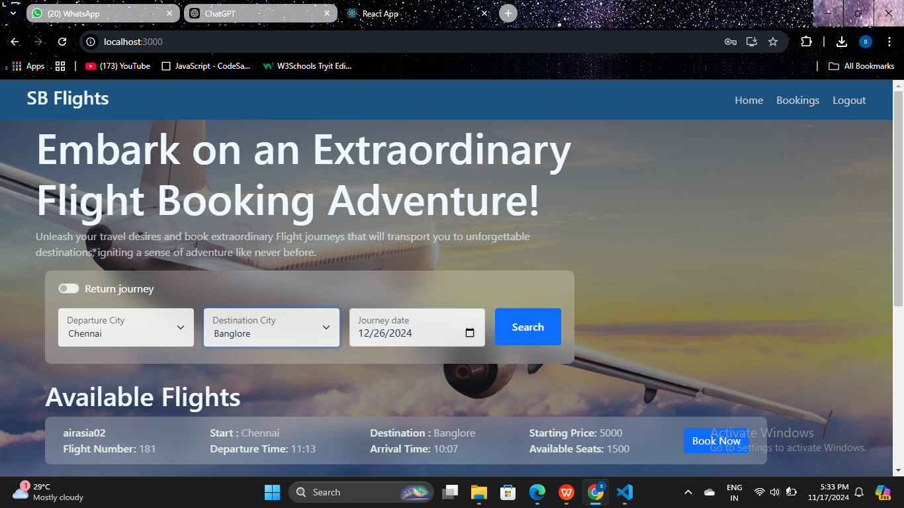

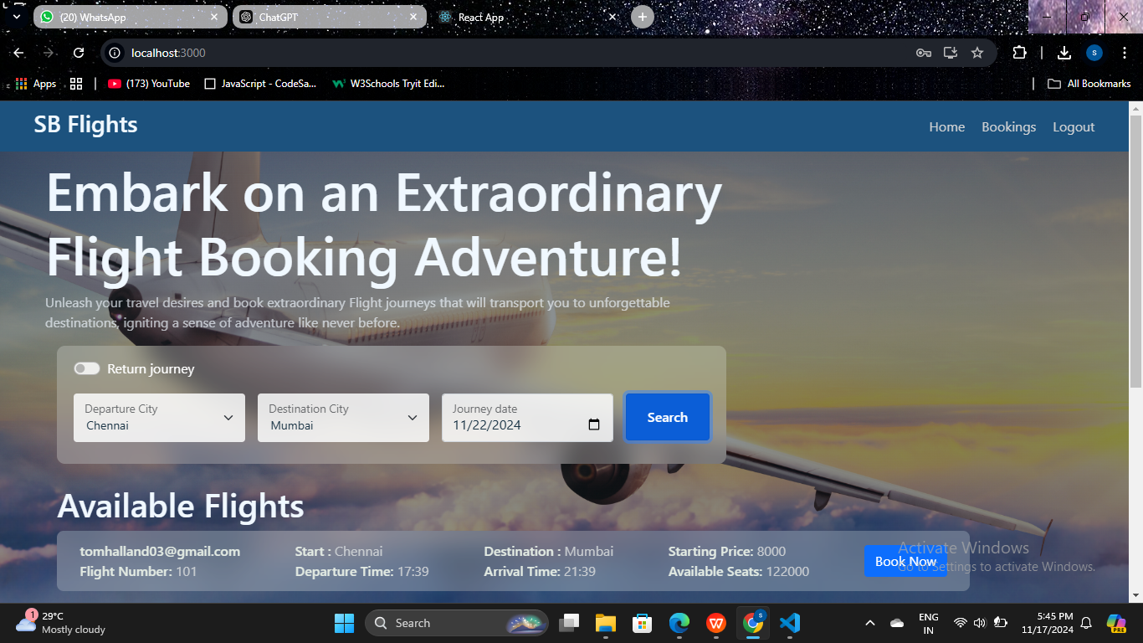

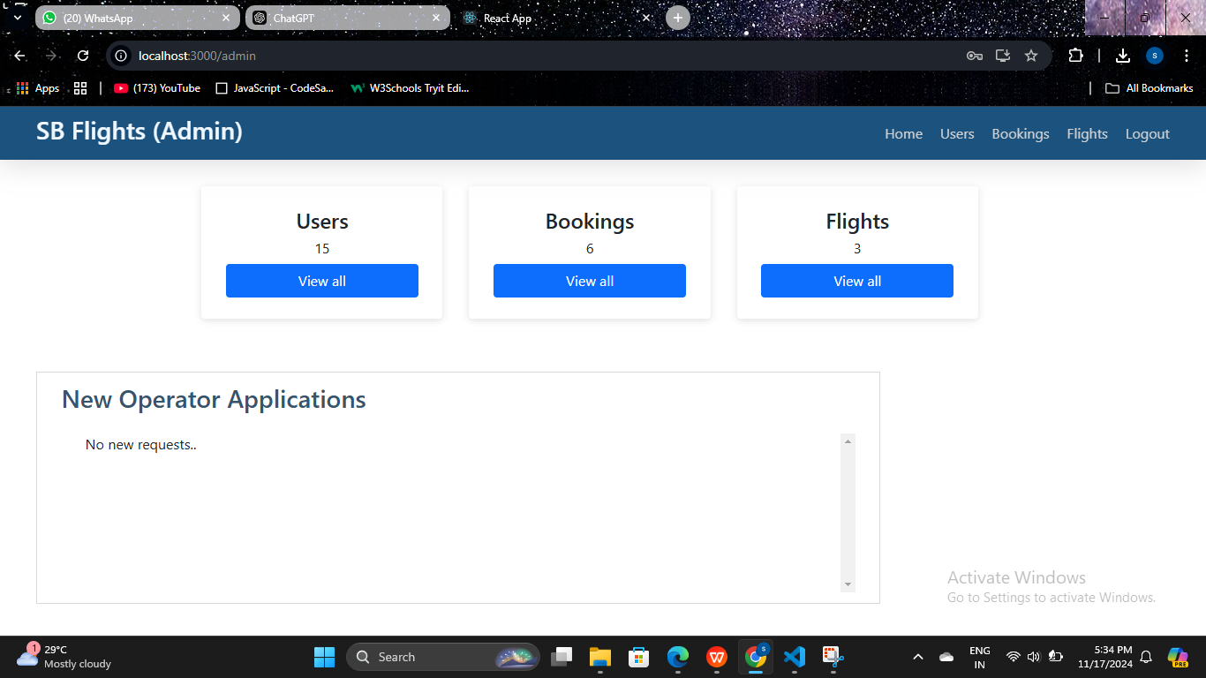

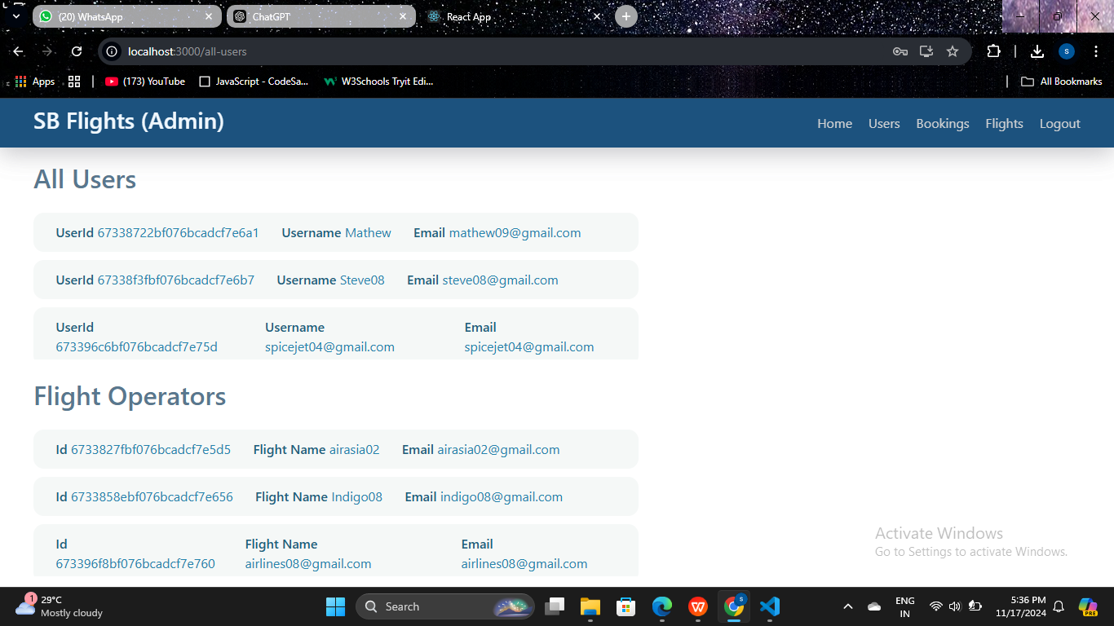

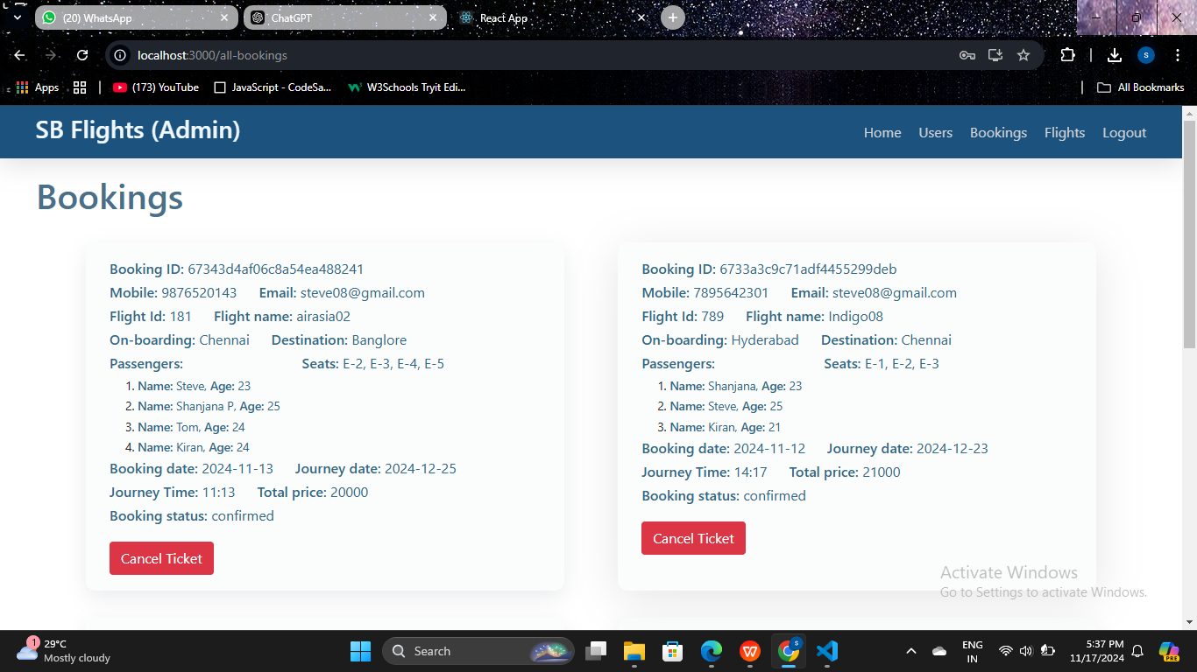

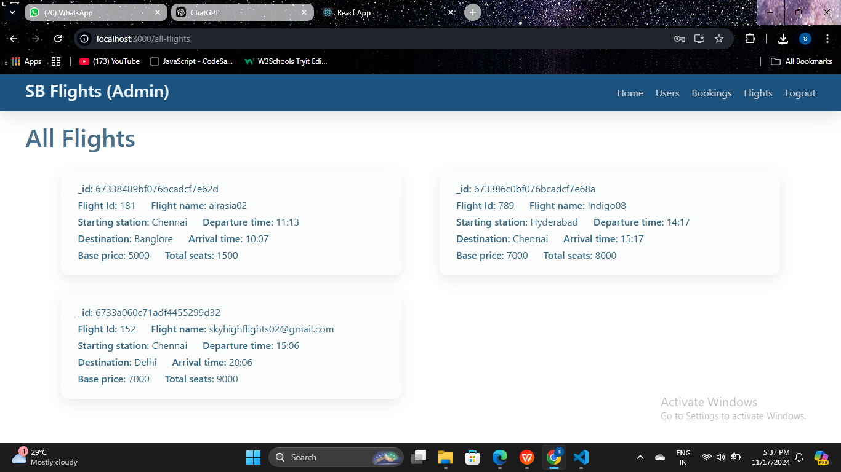

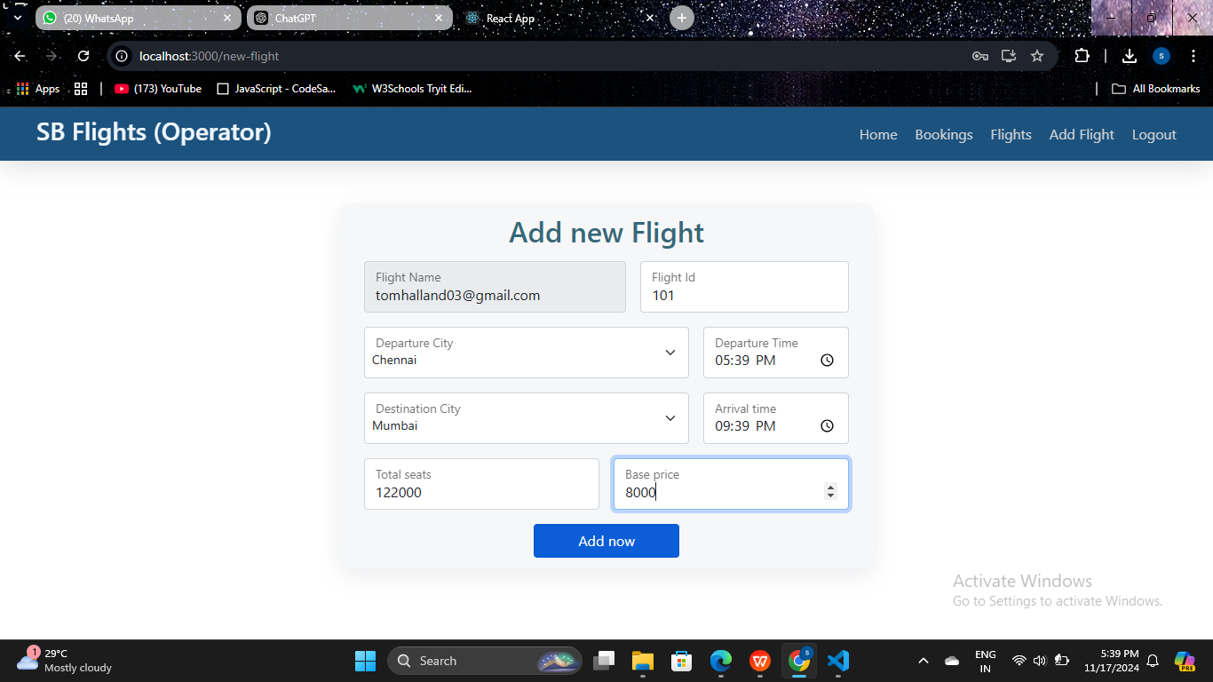

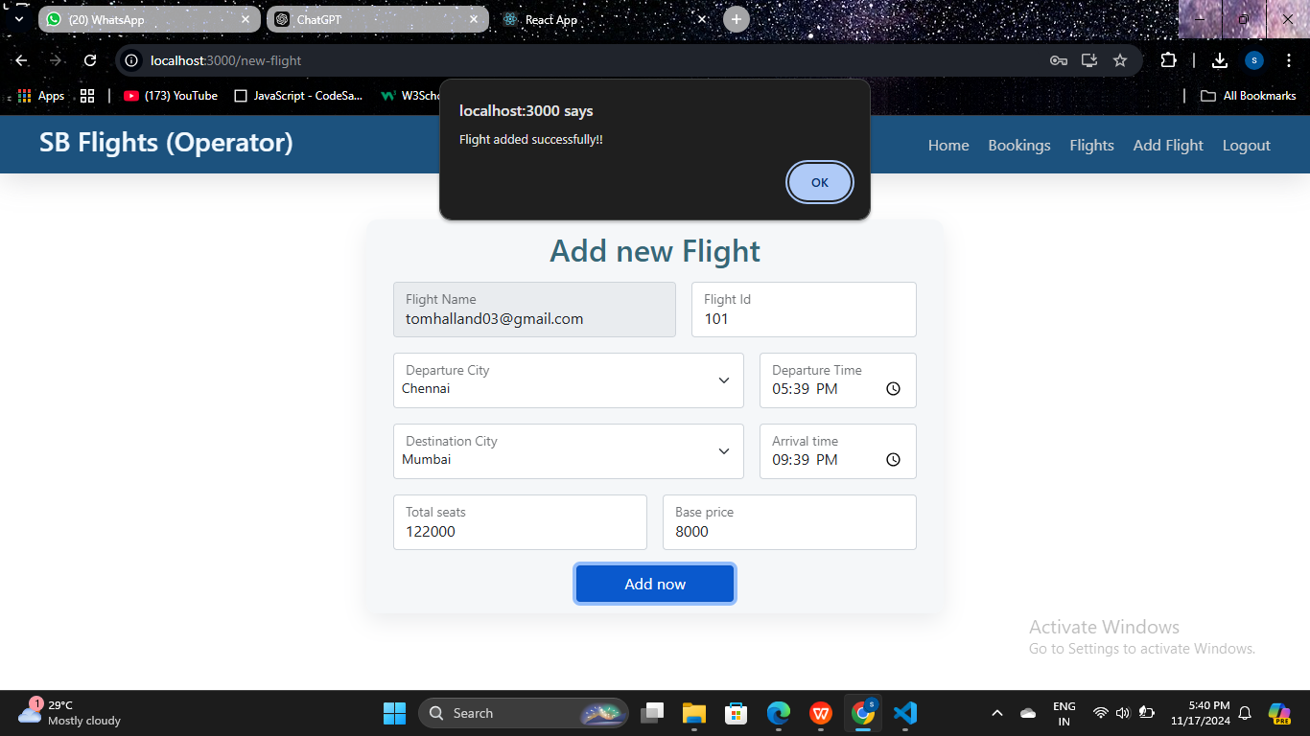

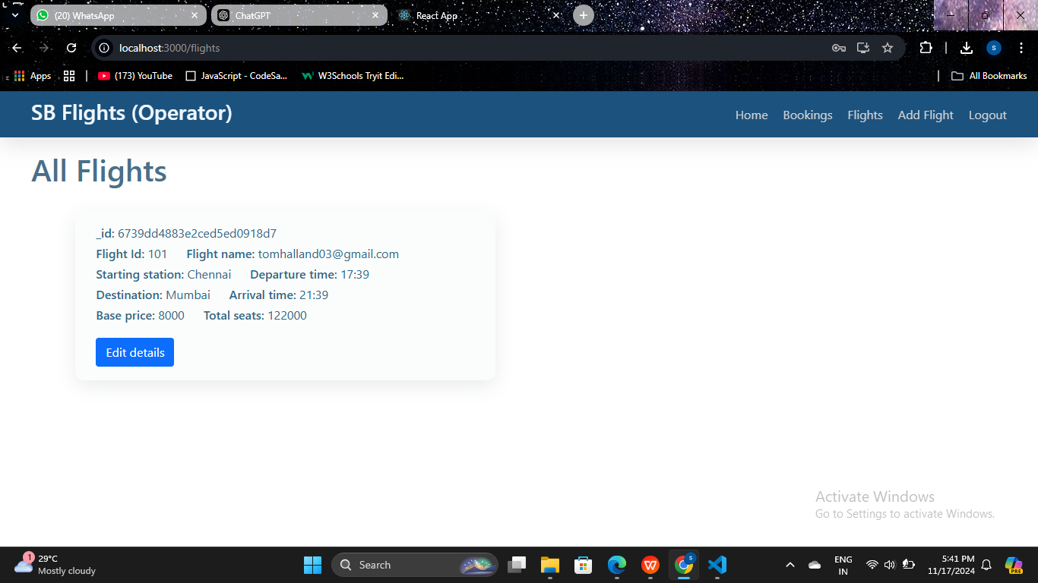

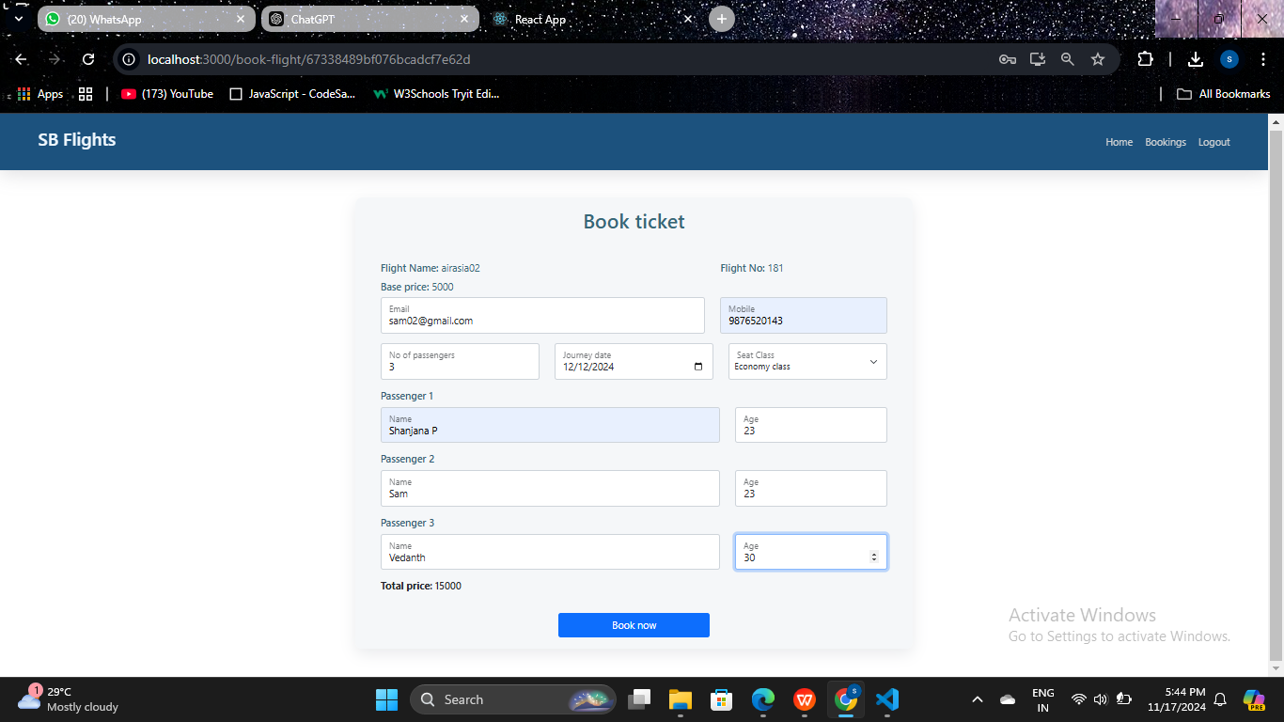

1. **TESTING OF OUR APPLICATION**

**Functional Testing**

We ensure that every feature of the application works as intended by verifying:

**User Authentication and Authorization**

Users can register, log in, log out, and reset passwords.

Role-based access controls (e.g., admin vs. customer) function correctly.

Flight Search and Booking

Users can search for flights based on criteria like date, destination, and price.

Booking functionality works seamlessly, including seat selection and passenger details entry.

**Payment Gateway Integration**

Payments are processed securely and correctly.

Users receive payment confirmations and invoices.

**Flight Management (Admin)**

Admins can add, update, or remove flights.

Admin dashboards display accurate metrics and data.

**2. Usability Testing**

**We verify the application’s user experience:**

**Ease of Navigation**

Ensure the interface is intuitive for users to search, book, and manage flights.

**Responsive Design**

Test the application on various devices (desktop, tablet, mobile) and screen resolutions.

**Accessibility**

Confirm compatibility with screen readers and compliance with WCAG standards for users with disabilities.

**3. Performance Testing**

We test the application's ability to handle varying loads:

**Load Testing**

Simulate multiple users searching and booking flights simultaneously to measure system performance.

**Stress Testing**

Push the system beyond its limits (e.g., very high traffic) to ensure it fails gracefully without data loss.

**Scalability Testing**

Check how the system scales with increased traffic or data growth (e.g., more flights or bookings).

**4. Security Testing**

We ensure the application protects user data and transactions:

Authentication and Authorization Security

Test for vulnerabilities like weak password policies and improper session management.

**Data Protection**

Verify sensitive information (e.g., passwords, payment data) is encrypted in transit and at rest.

**Penetration Testing**

Simulate attacks like SQL injection, XSS, and CSRF to identify and fix vulnerabilities.

**Token Validation**

Ensure JWTs or session tokens cannot be tampered with or reused.

**5. Integration Testing**

**We test how different modules interact:**

**Third-Party APIs**

Verify integration with APIs like flight data providers and payment gateways.

**Backend and Database**

Ensure the backend communicates correctly with the database, storing and retrieving information accurately.

**6. Database Testing**

**We validate database integrity and performance:**

Data Validation

Ensure all data entries, updates, and deletions reflect accurately in the database.

ACID Compliance

Confirm transactions follow atomicity, consistency, isolation, and durability principles.

Performance

Test database response times during high loads, such as complex flight searches.

**7. Cross-Browser Testing**

We test the application on different browsers to ensure compatibility:

Browsers

Verify functionality and appearance on Chrome, Firefox, Edge, and Safari.

Versions

Ensure compatibility with the latest and widely-used older versions of browsers.

**8. Regression Testing**

We run regression tests whenever updates are made to ensure existing features still work. Automated test scripts can be particularly helpful here to save time.

**9. API Testing**

**We test the backend APIs:**

Endpoint Functionality

Validate API responses (e.g., flight search, booking confirmation).

**Error Handling**

Ensure APIs return appropriate error codes and messages for invalid requests.

**Performance**

Measure response times and optimize API performance under load.

**10. User Acceptance Testing (UAT)**

We involve end-users to validate the application:

**Real-World Scenarios**

Test common use cases like booking a round-trip ticket or updating passenger details.

**Feedback Collection**

Gather user feedback on usability, performance, and overall satisfaction.

**11. Automation Testing**

For repetitive test cases (e.g., login functionality or booking flow), we use automated tools like Selenium or Cypress to improve efficiency.

**12. Testing Environments**

We perform tests in staging or pre-production environments that mimic the live setup to identify issues before deployment.

**These are the test cases which we have observed while developing our application:**

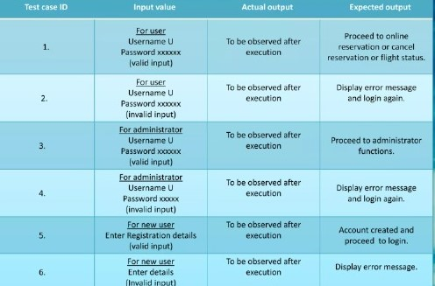

1. **SCREENSHOTS/DEMO VIDEO:**

**DEMO VIDEO LINK:**

<https://drive.google.com/drive/folders/1SFcQdXf70yT9xBYfnp9GSDBIEzisje-L?usp=sharing>

1. **OBSERVER ISSUES:**

**1. Technical Challenges**

**We integrate real-time flight data:**

While integrating APIs from multiple airlines, we face challenges like inconsistent data formats and handling API downtime. Ensuring smooth synchronization is a priority.

**We focus on scalability:**

As traffic surges during peak seasons, we work to ensure the application can scale seamlessly to handle the load without performance drops.

**We optimize search functionality:**

To enhance user experience, we develop fast and efficient algorithms for flight searches and implement advanced filtering options for pricing, timing, and airlines.

**We securely integrate payment gateways:**

Ensuring transactions are processed securely while handling failures or retries becomes a key focus for smooth payments.

**2. User Experience (UX) Concerns**

**We simplify complex interfaces:**

By designing an intuitive interface, we make it easy for users to search for flights, book tickets, and complete payments.

**We prioritize responsiveness:**

We ensure the application works flawlessly on different devices, including desktops, tablets, and mobile phones.

**We design seat selection:**

Creating an accurate and user-friendly seat map allows users to choose their preferred seats effortlessly.

**3. Security and Privacy Issues**

**We protect user data:**

By implementing encryption and secure storage, we safeguard sensitive user information like passwords, payment details, and travel history.

**We address authentication vulnerabilities:**

Using strong password policies, multi-factor authentication, and secure token management, we mitigate unauthorized access risks.

**We ensure compliance:**

We align with regulations like GDPR and PCI DSS to handle data and payments responsibly.

**4. Performance Challenges**

**We minimize response times:**

Optimizing backend operations and APIs helps us ensure fast searches and smooth booking processes.

**We prepare for concurrent users:**

To handle high volumes of traffic, we implement load balancing and caching mechanisms.

**We enhance database performance:**

We fine-tune our database to manage large datasets, such as flight schedules and booking records, efficiently.

**5. Business Logic Complexity**

**We handle dynamic pricing:**

By integrating with airline systems, we ensure real-time price updates and accurate fare calculations.

**We manage promotions and discounts:**

Implementing flexible rules for promo codes and seasonal offers allows us to attract and retain customers.

**We support complex itineraries:**

Multi-city bookings and flexible travel dates are accommodated through sophisticated itinerary management logic.

**6. Testing and Debugging Issues**

**We maintain environment consistency:**

By replicating production settings in staging environments, we ensure testing is accurate and reflective of real-world usage.

**We test third-party APIs:**

Simulating various conditions helps us handle incomplete or erroneous data from external sources gracefully.

**We automate repetitive tests:**

Automating login flows, booking processes, and other repetitive tasks saves time and increases accuracy.

**7. Operational Issues**

**We prevent booking conflicts:**

By ensuring real-time synchronization with airline systems, we reduce risks of double bookings or overbooking.

**We manage refunds and cancellations:**

Implementing detailed policies and workflows for partial refunds and penalties addresses customer needs effectively.

**We provide multilingual support:**

Supporting multiple languages ensures a better experience for our global user base.

**8. Regulatory and Compliance Challenges**

**We follow aviation standards:**

Compliance with industry-specific regulations and government policies ensures smooth operation and trustworthiness.

**We handle taxes and currencies:**

Our system accurately calculates taxes and handles currency conversions for international bookings.

**9. Communication and Notifications**

**We integrate reliable notifications:**

Sending timely emails or SMS for booking confirmations, cancellations, and delays keeps users informed.

**We improve error messaging:**

Providing clear and actionable error messages ensures users know how to resolve issues during booking or payment.

**10. Maintenance and Updates**

**We adapt to API changes:**

Frequent updates from third-party providers require us to monitor and modify integrations proactively.

**We enhance features iteratively:**

Adding new features, like loyalty programs or customer reviews, is done without disrupting existing functionality.

1. **FUTURE ENHANCEMENT:**

**Personalization and AI Integration**

**We implement AI-driven recommendations:**

Using machine learning, we provide personalized flight suggestions based on user preferences, past bookings, and travel trends.

**We enhance chat bots with NLP:**

By integrating advanced Natural Language Processing (NLP), we enable our chat bot to handle complex queries and offer real-time assistance for bookings and travel queries.

**We introduce dynamic pricing predictions:**

AI-powered tools can predict fare changes, helping users decide the best time to book their flights.

**2. Advanced Search and Filters**

**We enhance search capabilities:**

Incorporate filters for eco-friendly flights, stopover duration's, and baggage options to give users more control over their choices.

**We offer flexible date searches:**

Allow users to find the cheapest fares within a range of dates, supporting budget-conscious travelers.

**We enable multi-city and open-jaw itineraries:**

Improve the booking experience for complex travel plans, such as visiting multiple destinations in one trip.

**3. Sustainability Features**

**We highlight eco-friendly options:**

Show carbon emissions data and offer users the option to offset their carbon footprint by donating to environmental projects.

**We partner with green initiatives:**

Collaborate with airlines and organizations promoting sustainability to provide users with eco-conscious travel choices.

**4. Enhanced Payment Options**

**We support new payment methods:**

Enable digital wallets, cryptocurrency, and Buy Now, Pay Later (BNPL) options for flexibility in payment.

**We introduce loyalty programs:**

Develop a points-based rewards system for repeat customers to encourage long-term loyalty.

**We ensure global compatibility:**

Include localized payment methods and support for multiple currencies to cater to international travelers.

**5. Improved Post-Booking Services**

**We enable real-time itinerary updates:**

Notify users about flight delays, cancellations, or gate changes through push notifications, SMS, or email.

**We introduce self-service options:**

Allow users to manage bookings, change flight dates, or add extras like baggage or meals directly from the application.

**We integrate travel insurance:**

Offer insurance options during checkout for added convenience and peace of mind.

**6. Mobile-First Innovations**

**We improve offline functionality:**

Enable users to access their itineraries and e-tickets without internet connectivity.

**We adopt wearable technology:**

Develop companion apps for smartwatches to provide real-time updates and boarding notifications.

**We explore augmented reality (AR):**

Use AR for features like airport navigation or virtual seat previews.

**7. Multilingual and Multicultural Features**

**We add multilingual support:**

Expand language options to cater to a global audience and ensure translations are contextually accurate.

**We adapt culturally:**

Provide localized date formats, time zones, and holiday-specific promotions based on user regions.

**8. Social and Community Features**

**We enable group bookings:**

Introduce a feature for booking and managing group travel, such as corporate trips or family vacations.

**We allow reviews and ratings:**

Let users rate airlines, specific flights, or even seats to help others make informed decisions.

**We create social sharing options:**

Enable users to share their itineraries or travel experiences on social media directly from the application.

**9. Advanced Analytics for Admins**

**We provide actionable insights:**

Equip admins with dashboards to monitor trends, peak booking periods, and user behavior.

**We enable demand forecasting:**

Use analytics to predict demand and optimize pricing and flight schedules accordingly.

**We offer fraud detection:**

Implement tools to identify suspicious activities, such as unusual booking patterns or payment fraud.

**10. Emerging Technology Integration**

**We explore block chain for transparency:**

Used block chain technology for secure ticketing, ensuring transparency and reducing fraud.

**We integrate with Internet of Things (IoT):**

Enhance features like luggage tracking or in-flight connectivity through IoT integration.

**We incorporate voice assistants:**

Enable voice-based flight searches and bookings through platforms like Amazon Alexa or Google Assistant.

**11. Partnership Ecosystem**

**We add multi-modal transportation options:**

We have Combined flights with trains, buses, or ride-sharing services for seamless end-to-end travel planning.

**We collaborated with travel services:**

We have Offered bundled deals with hotels, car rentals, or tours to enhance convenience and increase revenue streams.

**We included visa assistance services:**

We have Partnered with visa processing platforms to help users with travel documentation requirements.

**12. Focus on Accessibility**

**We ensure inclusivity:**

This includes features like screen reader support, voice commands, and high-contrast modes for users with disabilities.

1. **CONCLUSION**

Building a flight booking application using the MERN stack is a comprehensive journey that covers planning, development, testing, and deployment. By following a structured approach, you can create a robust application that meets user needs, from simple flight searches to secure bookings and payments. Each phase, from backend API development to frontend integration, plays a critical role in the application's success.

Upon completion, the application will not only offer users a seamless booking experience but also provide room for scaling and feature enhancements. Incorporating user feedback, monitoring, and iterative improvements will keep the app reliable, competitive, and adaptable to future needs. This project journey not only delivers a valuable tool for users but also strengthens your skills in full-stack development, preparing you for more complex projects in the future.